

ENGLISH LANGUAGE TEST
GRADE SIX
Academic Year -2026/2027
Semester One -First Session
(Practice Exam - Unit 3: Buildings and Places)
Notice: | Number of pages: 9 | Time: 1½ hours
Notice: | Write your answers on the Test Paper
Prepared by Mohamed Mostafa Al Shorbagy, Regional Supervisor, Wusta Governorate
Important Instructions:
- Write your full name, class, and school name in the space provided.
- Read the questions carefully before starting your answers.
- Write with a blue or black pen only.
- Shade in the bubbles with a pencil.

Name
School |  | Class | 6/_____

ELEMENT |  | Marks |  | Signature with Name
 |  | In Numbers | In Words | First Marker | Second Marker
LISTENING | 10
GRM/VCB | 10
READING | 10
WRITING | 10
TOTAL | 40
LISTENING 1 (Items 1–5) (5 marks)
You are going to hear five short dialogues about buildings and places. Match the pictures with the dialogues. For each text, shade in the bubble under the correct option.

A. | 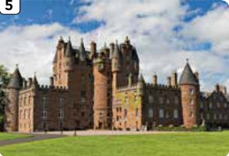 | B. | 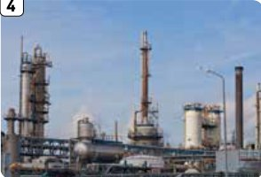 | C. | 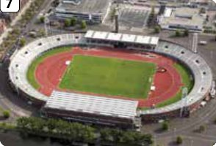
D. | 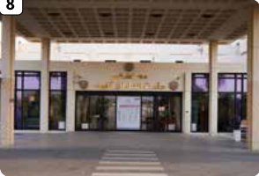 | E. | 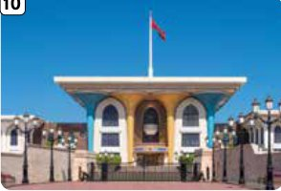 | F. | 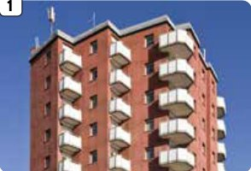

Pictures
Text | A | B | C | D | E | F
1.
2.
3.
4.
5.

LISTENING 2 (Items 6-10) (5 marks)
You are going to hear an interview between a teacher and Salim.
Listen, and shade in the bubble next to the correct option.

6.
 |  | An ancient palace |  | A new factory |  | A stadium
7.
 |  | At eight |  | At nine |  | At ten
8.
 |  | The café |  | The roof |  | Old paintings
9.
 |  | A secret room |  | A cupboard |  | An exit
10.
 |  | On the ground floor |  | On the first floor |  | On the roof

LISTENING
SCORE
LISTENING  SCORE | 10

VOCABULARY (Items 1–5) (5 marks)
Under each picture, write the correct word, as in the example.

e.g., | 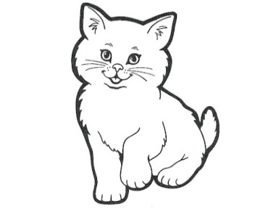 | 1. |  | 2. | 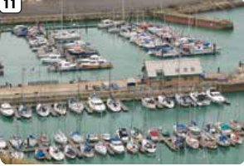
 | c a t |  | _ _ _ _ _ _ |  | _ _ _ _ _ _ _
3. | 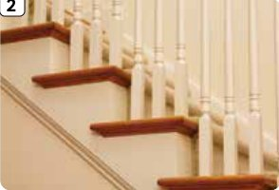 | 4. | 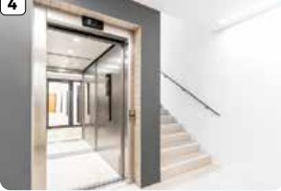 | 5. | 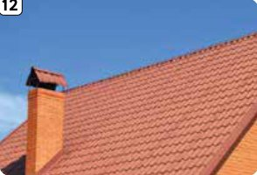
 | _ _ _ _ _ _ |  | _ _ _ _ |  | _ _ _ _

GRAMMAR (Items 6–10) (5 marks)
For each item, shade in the bubble next to the correct option.
6. A doctor is someone who / where___________ helps sick people.
7. A museum is a place who / where___________ you learn about history.
8. I were / was___________ reading when the phone rang.
9. They were walking / walk___________ to the lift.
10. She wasn't watch / watching___________ TV.

GRM/VCB
SCORE
GRM/VCB  SCORE | 10

READING 1 (Items 1–5) (5 marks)
Match the statements with the texts.
For each statement, shade in the bubble under the correct option.

A. | I am Hamed. Last weekend, I visited a castle with my family. We walked around its high walls and climbed some steps to a tower. I was taking a photo when I saw a small harbour below us. After that, we went to the gift shop. I bought a postcard for my friend.
B. | I am Lina. My aunt works in a hospital. Yesterday, I went there to meet her after work. I was waiting by the entrance when a doctor showed me the café. It was on the ground floor. I had a drink and read a book while I waited.
C. | I am Faisal. We live on the fifth floor of an apartment building. The lift was not working yesterday, so I took the stairs. On the second floor, I met a boy who was carrying a lizard. On the fourth floor, a girl was playing the flute. I enjoyed my walk upstairs!

 |  | Texts
 | Statements | A | B | C
1. | This person bought a postcard.
2. | This person saw a lizard.
3. | This person was waiting for an aunt.
4. | This person saw a harbour.
5. | This person lives on the fifth floor.

READING 2 (Items 6–10) (5 marks)
Read the text. Are the statements True or False? For each item, shade in the bubble under the correct option.

Last month, our class visited an old palace. We met our guide at the entrance. First, she took us upstairs to a room with paintings. She told us about the artist who painted them. I was looking at a picture when my friend noticed a little door. It was not a secret room. It was a cupboard for books! Later, we went downstairs to the café and wrote notes about our visit. I enjoyed learning about the past. For homework, I wrote a short story about the palace and its paintings.

 | Statements | True | False
6. | The class visited a palace last month.
7. | They met the guide on the roof.
8. | The artist painted pictures.
9. | The little door led to a secret room.
10. | The writer wrote a story for homework.

READING
SCORE
READING  SCORE | 10

WRITING 1 (5 marks)
Write a story of at least 50 words based on the following pictures. You can use the words in the box to help you. You can also put in more details to make your story lively and interesting.
Old building | Corridor | Door | Stairs
Room | Surprised

 |  | 
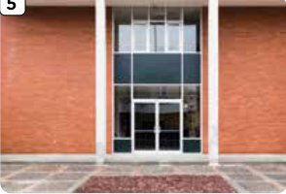 |  | 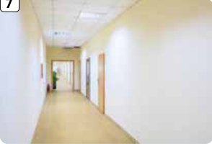

●

 |  |  |  | Marker A | Marker B | Average

WRITING 2 (5 marks)
Write a review about an interesting place in a town or city. Write at least 50 words.
Your writing should be clear and interesting.

 |  |  |  | Marker A | Marker B | Average

WRITING
SCORE
WRITING  SCORE | 10

