

ENGLISH LANGUAGE TEST
GRADE SIX
Academic Year -2026/2027
Semester One -First Session
(Practice Exam - Unit 1: Free-time Fun)
Notice: | Number of pages: 9 | Time: 1½ hours
Notice: | Write your answers on the Test Paper
Prepared by Mohamed Mostafa Al Shorbagy, Regional Supervisor, Wusta Governorate
Important Instructions:
- Write your full name, class, and school name in the space provided.
- Read the questions carefully before starting your answers.
- Write with a blue or black pen only.
- Shade in the bubbles with a pencil.

Name
School |  | Class | 6/_____

ELEMENT |  | Marks |  | Signature with Name
 |  | In Numbers | In Words | First Marker | Second Marker
LISTENING | 10
GRM/VCB | 10
READING | 10
WRITING | 10
TOTAL | 40
LISTENING 1 (Items 1–5) (5 marks)
You are going to hear five short dialogues about free-time activities. Match the pictures with the dialogues. For each text, shade in the bubble under the correct option.

A. |  | B. |  | C. | 
D. | 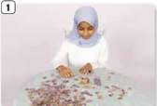 | E. | 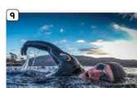 | F. | 

Pictures
Text | A | B | C | D | E | F
1.
2.
3.
4.
5.

LISTENING 2 (Items 6-10) (5 marks)
You are going to hear an interview between a teacher and Mazin.
Listen, and shade in the bubble next to the correct option.

6.
 |  | At school |  | At the sports centre |  | At home
7.
 |  | Every Monday |  | Every day |  | Twice a week
8.
 |  | Table tennis |  | Hockey |  | Swimming
9.
 |  | Plays football |  | Does puzzles |  | Watches cartoons
10.
 |  | Her school |  | Her hobbies |  | Her family trips

LISTENING
SCORE
LISTENING  SCORE | 10

VOCABULARY (Items 1–5) (5 marks)
Under each picture, write the correct word, as in the example.

e.g., | 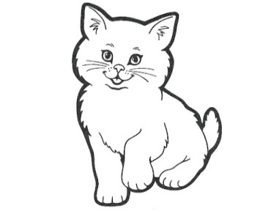 | 1. |  | 2.
 | c a t |  | _ _ _ _ _ _ |  | _ _ _ _ _ _ _
3. |  | 4. |  | 5. | 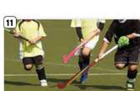
 | _ _ _ _ _ |  | _ _ _ _ _ _ |  | _ _ _ _ _ _

GRAMMAR (Items 6–10) (5 marks)
For each item, shade in the bubble next to the correct option.
6. Look! Salim does / is doing___________ karate in the garden.
7. We go / are going___________ swimming every Friday.
8. She loves making / is loving___________ models of cars.
9. How about go / going___________ to the video club?
10. I don't believe / 'm not believing___________ it! You do six sports!

GRM/VCB
SCORE
GRM/VCB  SCORE | 10

READING 1 (Items 1–5) (5 marks)
Match the statements with the texts.
For each statement, shade in the bubble under the correct option.

A. | My name is Salim. I love sport, but I never play football. Every Friday I go to the sports centre with my friends. We play table tennis there. It is my favourite sport because it is fast and fun.
B. | Hello! I am Noor. I don't like ball games. In my free time I like quiet things. I have 300 cards with pictures of animals. My grandmother gave me fifty of them. Sometimes I do puzzles with her too.
C. | My name is Khalid. Some people think my hobby is strange. I make small models of cars and planes from wood. It is difficult, but I love it. Last month I made a big model of a plane for our school show.

 |  | Texts
 | Statements | A | B | C
1. | This person got some of his or her cards from a family member.
2. | This person plays a sport with a small ball.
3. | This person showed his work to people at school.
4. | This person does not play football.
5. | This person has three hundred things at home.

READING 2 (Items 6–10) (5 marks)
Read the text. Are the statements True or False? For each item, shade in the bubble under the correct option.

Last month our school started a new Free-time Club. Students meet every Wednesday after school. In the first week, fifteen students came. Some students played table tennis in the gym, and others did puzzles in the library. Aisha brought her camera because she loves photography. She made a short video about the club, and now twenty-five students come every week. The club leader, Mr Salim, says students must bring a helmet if they want to go cycling on Fridays. "The club helps students stay healthy and make new friends," he says.

 | Statements | True | False
6. | The club meets on Wednesdays.
7. | Thirty students came in the first week.
8. | Aisha made a video about the club.
9. | Students cycle in the gym on Fridays.
10. | Mr Salim thinks the club is good for students.

READING
SCORE
READING  SCORE | 10

WRITING 1 (5 marks)
Write a story of at least 50 words based on the following pictures. You can use the words in the box to help you. You can also put in more details to make your story lively and interesting.
Rainy | no Wi-Fi | Piano | Friends
Sing | Happy

 |  | 
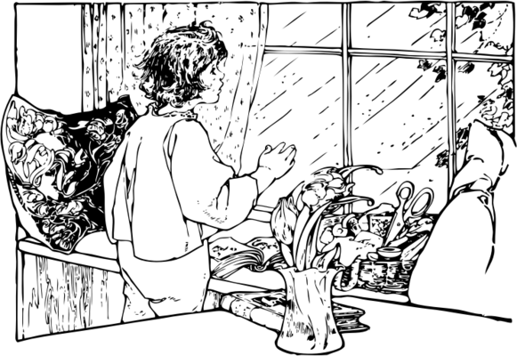 |  | 

●


 |  |  |  | Marker A | Marker B | Average

WRITING 2 (5 marks)
Write a review about a sport or a hobby you like. Write at least 50 words.
Your writing should be clear and interesting.

 |  |  |  | Marker A | Marker B | Average

WRITING
SCORE
WRITING  SCORE | 10

