
ENGLISH LANGUAGE TEST
GRADE FIVE
Academic Year -2026/2027
Semester One-First Session
(Practice Exam - Unit 3: Let's Explore!)
Notice: | Number of pages: 8 | Time: 1½ hours
Notice: | Write your answers on the Test Paper
Prepared by Mohamed Mostafa Al Shorbagy, Regional Supervisor, Wusta Governorate
Important Instructions:
- Write your full name, class, and school name in the space provided.
- Read the questions carefully before starting your answers.
- Write with a blue or black pen only.
- Shade in the bubbles with a pencil.

Name
School |  | Class | 5/_____

ELEMENT |  | Marks |  | Signature with Name
 |  | In Numbers | In Words | First Marker | Second Marker
LISTENING | 10
GRM/VCB | 10
READING | 10
WRITING | 10
TOTAL | 40

LISTENING 1 (Items 1–5) (5 marks)
You are going to hear five short dialogues about space. Match the pictures with the dialogues. For each text, shade in the bubble under the correct option.

A. |  | B. | 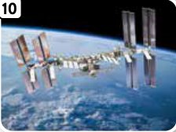 | C. | 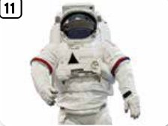
D. | 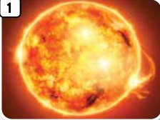 | E. | 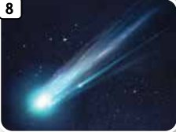 | F. | 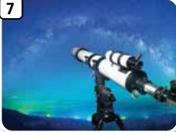

Pictures
Text | A | B | C | D | E | F
1.
2.
3.
4.
5.

LISTENING 2 (Items 6-10) (5 marks)
You are going to hear a teacher talking to her class.
Listen, and shade in the bubble next to the correct option.

6. | Tomorrow the club will make ...
 |  | a model of the solar system |  | a rocket cake |  | a telescope
7. | The club will meet in ...
 |  | Room 17 |  | the science lab |  | the garden
8. | Students should bring ...
 |  | food and water |  | a spacesuit |  | cardboard and coloured paper
9. | They will use the telescope ...
 |  | before the models |  | after the models |  | next month
10. | The club starts at ...
 |  | four o'clock |  | three o'clock |  | five o'clock

LISTENING
SCORE
LISTENING  SCORE | 10

VOCABULARY (Items 1–5) (5 marks)
Match the pictures with the words. For each picture, shade in the bubble under the correct option.

1. |  |  |  | 2. |  |  |  | 3.
 |  |  |  |  |  |  |  | 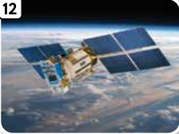
 |  | 4. |  |  |  | 5.
 |  |  |  |  |  | 

 | comet | rocket | satellite | spacesuit | star | telescope
1.
2.
3.
4.
5.

GRAMMAR (Items 6–10) (5 marks)
For each item, shade in the bubble next to the correct option.
6. I will / was___________ make a model tomorrow.
7. She won't posts / post___________ a letter.
8. Will / Are___________ you wear a spacesuit?
9. How deep / tall___________ is your brother?
10. How far / wide___________ is the town from the school?

GRM/VCB
SCORE
GRM/VCB  SCORE | 10

READING 1 (Items 1–5) (5 marks)
Match the texts with the pictures. For each text, shade in the bubble under the correct option.

A. |  | B. |  | C.

D. |  | E. | 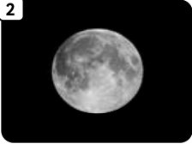

 |  | Pictures
 | Texts | A | B | C | D | E
1. | This is a star. It gives the Earth light and heat.
2. | We live on this planet.
3. | An astronaut wears this outside the station.
4. | You can see this at night. It goes around the Earth.
5. | Astronauts use this to fly into space.

READING 2 (Items 6–10) (5 marks)
Read the text. Are the statements True or False?
For each item, shade in the bubble under the correct option.

Our class will visit the Space Explorers Club tomorrow. First, we will make a model of the solar system. We will use cardboard and coloured paper. Then we will look through a telescope. We hope to see the Moon. We will not go outside in a spacesuit! After the visit, I will write a blog post about the club. I am excited because I love learning about space.

 | Statements | True | False
6. | The class will visit the club tomorrow.
7. | They will make a model of a museum.
8. | They will use cardboard and coloured paper.
9. | They will wear spacesuits outside.
10. | The writer will write a blog post.

READING
SCORE
READING  SCORE | 10

WRITING 1 (5 marks)
Write a descriptive text of at least 40 words on the following topic:
“A space birthday party”
Write about your plans for the party. What will you do? What won't you do? Use will, won't and future time words.

Your writing should be clear and organised.

 |  |  |  | Marker A | Marker B | Average

WRITING 2 (5 marks)
Complete the following task. Write at least 40 words.
Situation: Imagine you are an astronaut. Write a blog post about food, clothes, repairs or hobbies in space. Include at least one question. Use invented details, not personal information.
Your writing should be clear and organised.

 |  |  |  | Marker A | Marker B | Average

WRITING
SCORE
WRITING  SCORE | 10

