ENGLISH LANGUAGE TEST
GRADE ELEVEN
Semester One
First Session
(Practice Exam - Theme 4: Innovation)

Name
School |  | Class

Write your answers on the Test Paper
Time: 2½ hours Pages: 14

ELEMENT |  | Marks |  | Red Marker | Green Marker | Blue Checker
 |  |  |  | Name | Name | Name
LISTENING | 20
READING | 20
WRITING 1 | 10
WRITING 2 | 10
TOTAL | 60
Prepared by Mohamed Mostafa Al Shorbagy, Regional Supervisor, Wusta Governorate
LISTENING 1 (Items 1-10) (10 marks)
You are going to hear a conversation between two students, Fahad and Zainab.
Task One: Listen, and shade in the bubble next to the correct option.

1. | What is Fahad's project?
 |  | an irrigation system |  | a cleaning robot |  | a solar cooker
2. | How long ago did Fahad order the parts?
 |  | five days ago |  | nine days ago |  | two weeks ago
3. | What does Zainab advise Fahad to do?
 |  | write more emails |  | cancel the order |  | call the company
4. | How will the robot find the rubbish?
 |  | follow a black line |  | use a small camera |  | smell the rubbish
5. | Who will help Zainab with programming?
 |  | her teacher |  | her brother |  | her uncle
6. | Where will the students meet at 2.30?
 |  | at the workshop |  | at the school gate |  | at the science lab

Task Two: For each item, shade in the bubble to indicate whether the statement is True/False.
 | Statements | True | False
7. | Fahad's uncle waters his date farm every evening.
8. | The company answered Fahad's second email.
9. | Zainab's robot will be made of new parts.
10. | The two students will share one stand at the fair.

LISTENING 2 (Items11-20) (10 marks)
You are going to hear a student telling his class how he became a young inventor.
Part One: For each item, write a short answer (not more than FOUR WORDS).

11. Where did the inventor's family live?

________________________________________________

12. How many sections did the box have?

___________________________________________________

13. Who said the alarm was not enough?

___________________________________________________

14. Who bought better tools?

__________________________________________________

15. What did his grandmother name the box?

__________________________________________________

16. How long did the judges test the box?

_________________________________________________

Part Two: For each item, completer the missing words (not more than three words).
17. The nearest clinic was twenty ____________ away.
18. The box could send a message to his mother's ____________.
19. The first box opened at the wrong ____________.
20. The inventor keeps the broken boxes on a ____________.

LISTENING
SCORE
LISTENING  SCORE | 20
READING 1 (Items 1-10) (10 marks)
Read the following Text. Then complete the tasks.
Every few months, a newspaper article asks the same worried question: is new technology making us stupid? Calculators will destroy mathematics, we are told; navigation apps will destroy our sense of direction; and now artificial intelligence will destroy thinking itself. The headlines are dramatic, and they are designed to frighten parents and teachers. But how much truth is there in these fears?
The worry is not new. When writing was invented, some teachers complained that students would stop using their memories. When printing arrived, people feared that cheap books would fill young minds with rubbish. Yet each technology freed the human brain for bigger things. The same complaints return with every new invention, and every time they sound fresh and frightening. Socrates himself warned that writing would destroy memory, yet his own ideas survived only because someone wrote them down. Nobody today says that books made us stupid.
There is, however, a real problem hidden inside the modern version of the fear. A calculator does mathematics for you, but a student who understands the mathematics can check the answer. A navigation app is dangerous only when the driver follows it blindly into the sea. A spell-checker corrects your spelling, but a writer who never learned to spell cannot tell when it is wrong. The tool is not the danger; the danger is switching off your own judgment.

READING 1 (continued)

Research on this question is mixed. Some studies show that people who depend completely on their phones remember fewer phone numbers and directions. Other studies show that the same people are better at finding and judging new information - a skill that matters far more today than memorising facts. The truth, as usual, sits somewhere between the two extremes.
The sensible answer, then, is balance. Technology itself is neither good nor bad. Teachers have an important role: they must show students when to use the tool and when to use the brain. Use technology as a bicycle for the mind: it carries you further and faster, but you still have to pedal. Students should first learn to do things themselves - calculate, remember, find their way - and then use the tools. A machine that does everything for you makes you weaker; a machine that works with you makes you stronger. The question is not whether technology makes us stupid. It is whether we choose to use it wisely. That choice belongs to us, not to the machines.

Task One: For each item, write a short answer (not more than FOUR WORDS).

1. What will calculators destroy, according to the articles?
__________________________________________________
2. Who are the headlines designed to frighten?
___________________________________________________
3. What would students stop using, teachers once feared?
__________________________________________________
4. What is dangerous only when followed blindly?
___________________________________________________
5. What do phone-dependent people remember fewer of?
___________________________________________________
6. What does the writer compare technology to?
___________________________________________________

Task Two: For each item, shade in the bubble to indicate whether the statement is True/False.
 | Statements | True | False
7. | People once feared cheap books would fill young minds with rubbish.
8. | All research shows that phones weaken people's memory.
9. | The writer says each technology freed the brain for bigger things.
10. | The writer believes machines should do everything for students.

READING 2 (Items 11-20) (10 marks)
Read the text. Then complete the tasks.

Good morning, everyone. Today I want to talk about a technology that is changing the way we live: the smart home. Ten years ago, it sounded like science fiction; today, it is in the shops.
Imagine walking into a room, and the lights come on, the temperature changes to what you like, and your favourite music begins to play. In a smart home, appliances such as refrigerators, washing machines and air conditioners have small computers inside them. They are all connected together, and you can control them with your voice, or with your mobile phone, even when you are far away from home.
A smart fridge, for example, can tell you what food you need to buy, and some fridges can even order food from the shop over the Internet. Coffee makers, lights and air conditioners can be programmed to turn on at certain times. You can wake up in the morning, and your coffee is already waiting for you.
Smart homes can also save money. They turn off lights and air conditioners when nobody is in the room. With today's high energy prices, this can save a family a large amount every month, and the system tells you exactly how much you are saving. Some families in Muscat report saving fifteen per cent on their electricity bills.

READING 2 (continued)

However, smart homes are not perfect. First, they are still expensive. Until recently, only the rich could afford a complete system. Prices are falling year by year, but a full smart home still costs a lot of money.
Second, there are safety questions. Smart devices are connected to the Internet, so a stranger could try to control them. Experts advise people to use strong passwords and to update their devices regularly. A weak password is like leaving your front door open.
Third, there is the question of dependence. If everything in your house is automatic, what happens when the system stops working? Some people forget how to do simple things themselves. So are smart homes a good idea? In my opinion, yes - if we use them wisely. Let technology do the boring jobs, like turning off lights, but keep control of your own life. The best smart home is one that serves its family, not one that the family serves. Most future homes will have some smart features, so learn about them now, and you will be ready. Teach your parents too - many older people find the new technology confusing at first. Thank you.

Task One: shade in the bubble next to the correct option.

11. | What is inside smart home appliances?
 |  | small computers |  | large batteries |  | secret cameras
12. | What can some smart fridges order?
 |  | clothes |  | food |  | tickets
13. | The word 'afford' in paragraph 5 is closest in meaning to:
 |  | sell |  | pay for |  | repair
14. | The word 'dependence' in paragraph 7 is closest in meaning to:
 |  | needing it too much |  | saving money |  | complete freedom
15. | How do smart homes save money?
 |  | turn off unused devices |  | order cheaper food |  | give free internet
16. | What is the teacher's final advice?
 |  | avoid smart homes |  | use them wisely |  | buy everything now

Task Two: Match the four paragraphs on the left with the main ideas in the box. (There are three extra ideas in the box.)

17. | Paragraph 2 | ___ | A. | what smart homes can do
18. | Paragraph 3 | ___ | B. | examples of smart devices
19. | Paragraph 4 | ___ | C. | the history of computers
20. | Paragraph 6 | ___ | D. | saving money and energy
 |  |  | E. | cooking with technology
 |  |  | F. | safety and passwords
 |  |  | G | smart homes in Oman

READING
SCORE
READING  SCORE | 20

WRITING 1 (10 marks) Write an informative text of at least 100 words. Use ALL the information in the graph/figure.
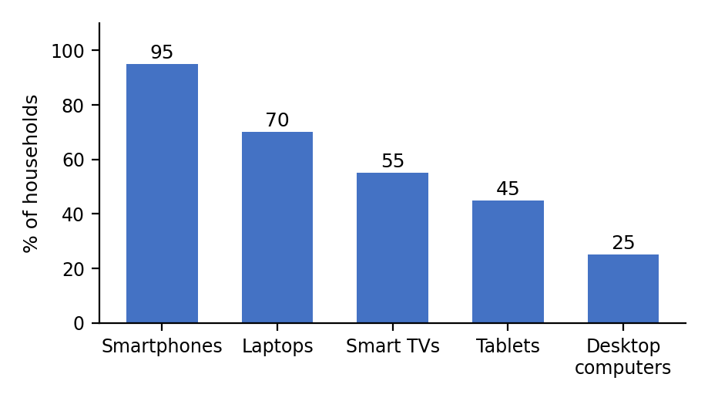
Devices used to access the Internet in Oman, 2025 (% of households)

Your writing should be correct and organised.

WRITING 1 (continued)

 |  |  |  | Marker A | Marker B | Average

WRITING 2 (10 marks)
Complete the following task. Write at least 100 words.
Situation: You ordered a smartwatch from an online company two weeks ago. When it arrived, it did not work at all. You have written two emails to the company, but nobody has answered. You paid 45 rials for the watch.

Task: Write a formal letter/ an email to the manager of the company, explaining the problem and asking for a replacement or a refund.

Your writing should be clear and organised.

WRITING 2 (continued)

 |  |  |  | Marker A | Marker B | Average

WRITING
SCORE
WRITING  SCORE | 20

