ENGLISH LANGUAGE TEST
GRADE ELEVEN
Semester One
First Session
(Practice Exam - Theme 3: Travellers and Tourists)

Name
School |  | Class

Write your answers on the Test Paper
Time: 2½ hours Pages: 14

ELEMENT |  | Marks |  | Red Marker | Green Marker | Blue Checker
 |  |  |  | Name | Name | Name
LISTENING | 20
READING | 20
WRITING 1 | 10
WRITING 2 | 10
TOTAL | 60
Prepared by Mohamed Mostafa Al Shorbagy, Regional Supervisor, Wusta Governorate
LISTENING 1 (Items 1-10) (10 marks)
You are going to hear a conversation between two students, Salim and Noor.
Task One: Listen, and shade in the bubble next to the correct option.

1. | Why is Noor excited?
 |  | She passed her exams |  | She is going to Salalah |  | She won a prize
2. | When is Noor's family leaving?
 |  | this Thursday |  | next Thursday |  | next Friday
3. | Where will the family stop on the way?
 |  | Nizwa |  | Thumrait |  | Sur
4. | Who booked the hotel in Salalah?
 |  | her father |  | her uncle |  | a travel agent
5. | What does Noor want to see at Wadi Darbat?
 |  | the caves |  | the waterfall |  | the birds
6. | What will Noor's aunt make for dinner?
 |  | mishkak and halwa |  | biryani and salad |  | pizza and cake

Task Two: For each item, shade in the bubble to indicate whether the statement is True/False.
 | Statements | True | False
7. | Noor's little sister has already packed her beach things.
8. | The family returns home on the first day of school.
9. | Noor's brother takes excellent photos with his phone.
10. | Salim's father will drive the family car to Salalah.

LISTENING 2 (Items11-20) (10 marks)
You are going to hear a student telling his class about an unforgettable journey.
Part One: For each item, write a short answer (not more than FOUR WORDS).

11. Who printed the itinerary for the journey?

________________________________________________

12. What did the grandmother carry on her lap?

___________________________________________________

13. Where did the car stop working?

___________________________________________________

14. What was broken in the car?

__________________________________________________

15. Who repaired the car?

__________________________________________________

16. When did the family reach Salalah?

_________________________________________________

Part Two: For each item, completer the missing words (not more than three words).
17. Hamad's grandmother had not seen Salalah since she was a young ____________.
18. The family could not phone for help because there was no ____________.
19. The Bedouin's wife brought cold water, fresh dates and ____________.
20. The mechanic refused any ____________ for the repair.

LISTENING
SCORE
LISTENING  SCORE | 20
READING 1 (Items 1-10) (10 marks)
Read the following Text. Then complete the tasks.
Open any social media page today and you will see them: people who call themselves 'travellers', never 'tourists'. But is there really a difference, or is it just a fashionable word? The word appears in every advertisement, every blog and every online profile.
The tourist, according to the popular image, arrives in an air-conditioned bus, takes photographs in front of famous buildings, buys plastic souvenirs and returns home without speaking to a single local person. The traveller, in contrast, carries a backpack, eats street food, learns ten words of the language and returns with stories about 'real' life. The 'traveller' also loves to say that he never plans anything, and that guidebooks are for amateurs. Travel companies have noticed this attitude, and now every package holiday is sold as an 'authentic experience'.
There is some truth behind the fashion. Studies show that visitors who stay in family guesthouses and eat in local restaurants leave far more money in the local economy than those who spend their days inside international hotels. Small businesses - the boat owner in Sur, the honey seller in the mountains of Jebel Akhdar, the woman weaving baskets in Bahla - benefit directly from these visitors. One study of a popular tourist region found that eighty per cent of the money spent in international resorts left the country within a year, while money spent in local guesthouses stayed in the village.
But the proud 'traveller' can be just as blind as the tourist. Sleeping in a tent does not automatically teach you anything about a country. Some travellers collect countries the way children collect stickers, racing through five cities in seven days and learning nothing at all. They cannot name a single person they met. They return home with hundreds of photographs but not one real conversation.

READING 1 (continued)

In the end, the label does not matter. What matters is curiosity and respect. A tourist on a bus tour who asks questions and listens carefully learns more than a backpacker who never puts down his phone. Oman welcomes both - the family in the five-star resort and the student in the mountain guesthouse - because both bring income, create jobs and take home memories. A tourist who smiles at the market seller and tries three words of Arabic does more for understanding between cultures than a hundred silent backpackers. Both can harm a place, or honour it. The real difference is not in the luggage you carry, but in the mind you bring.

Task One: For each item, write a short answer (not more than FOUR WORDS).

1. What does the tourist buy, according to the popular image?
__________________________________________________
2. How many words of the language does the traveller learn?
___________________________________________________
3. Where do visitors who support the local economy stay?
__________________________________________________
4. What does the woman in Bahla weave?
___________________________________________________
5. What do some travellers collect like stickers?
___________________________________________________
6. According to the writer, what matters more than the label?
___________________________________________________

Task Two: For each item, shade in the bubble to indicate whether the statement is True/False.
 | Statements | True | False
7. | Travel companies now sell package holidays as 'authentic experiences'.
8. | International hotels benefit directly from visitors who stay in local places.
9. | Travellers who race through five cities in seven days learn a lot.
10. | The writer believes a curious tourist learns more than a backpacker on his phone.

READING 2 (Items 11-20) (10 marks)
Read the text. Then complete the tasks.

Good morning, everyone, and welcome to Sunway Travel. Many of you are planning your first big holiday without your parents, so today I will share some simple advice that experienced travellers follow.
First, choose the type of holiday that really suits you. Do you want adventure, like white water rafting or hiking in the mountains? Or do you prefer culture - museums, old forts and local festivals? Perhaps you simply want a quiet beach. A family with young children needs something very different from a group of university friends. If you choose the wrong type of holiday, even the best destination will disappoint you.
Second, book early. Flights and hotels become more expensive as the dates get closer, and the best places fill up quickly. Travellers who book three or four months ahead usually get much better prices and more choice. Many airlines also offer their cheapest seats half a year before departure, so a little planning saves a lot of money.
Third, check your documents. Make sure your passport is valid for at least six months, and find out whether you need a visa. Every year, travellers arrive at the airport and discover they cannot fly because of a document problem. It is a terrible way to start a holiday. Check the rules again one week before you travel, because they sometimes change without warning.

READING 2 (continued)

Now, some advice about packing. The most common mistake new travellers make is that they pack too much. You do not need five pairs of shoes! Take light, comfortable clothes, and remember you can buy almost anything at your destination. Heavy bags also cost extra money on most flights these days.
About money: carry only a little cash with you. Use a bank card for hotels and big purchases, and keep a second card in a different bag in case one is lost. Tell your bank before you travel, or they may think your card was stolen and block it.
Finally, respect the country you visit. Learn a few words of the local language, dress in a way that respects local customs, and always ask before you photograph people. Travellers who show respect are welcomed back; tourists who ignore local culture give all visitors a bad name. So, to sum up: choose the right holiday, book early, check your documents, pack light, carry a little cash, and respect local customs. Plan well, then relax and enjoy every moment. Thank you, and happy travels!

Task One: shade in the bubble next to the correct option.

11. | What should travellers choose first?
 |  | the type of holiday |  | the hotel |  | the airline
12. | What is the most common packing mistake?
 |  | they pack too much |  | they pack too little |  | they forget tickets
13. | The word 'valid' in paragraph 4 is closest in meaning to:
 |  | acceptable |  | new |  | stolen
14. | The word 'disappoint' in paragraph 2 is closest in meaning to:
 |  | please |  | surprise |  | make unhappy
15. | How much cash should travellers carry?
 |  | all their money |  | only a little |  | none at all
16. | What is the speaker's final advice?
 |  | stay at home |  | plan well, then relax |  | travel alone

Task Two: Match the four paragraphs on the left with the main ideas in the box. (There are three extra ideas in the box.)

17. | Paragraph 2 | ___ | A. | choosing the right holiday
18. | Paragraph 3 | ___ | B. | booking before prices rise
19. | Paragraph 5 | ___ | C. | what to wear on the plane
20. | Paragraph 7 | ___ | D. | packing smartly
 |  |  | E. | the history of tourism
 |  |  | F. | money and safety
 |  |  | G | being a respectful visitor

READING
SCORE
READING  SCORE | 20

WRITING 1 (10 marks) Write an informative text of at least 100 words. Use ALL the information in the graph/figure.
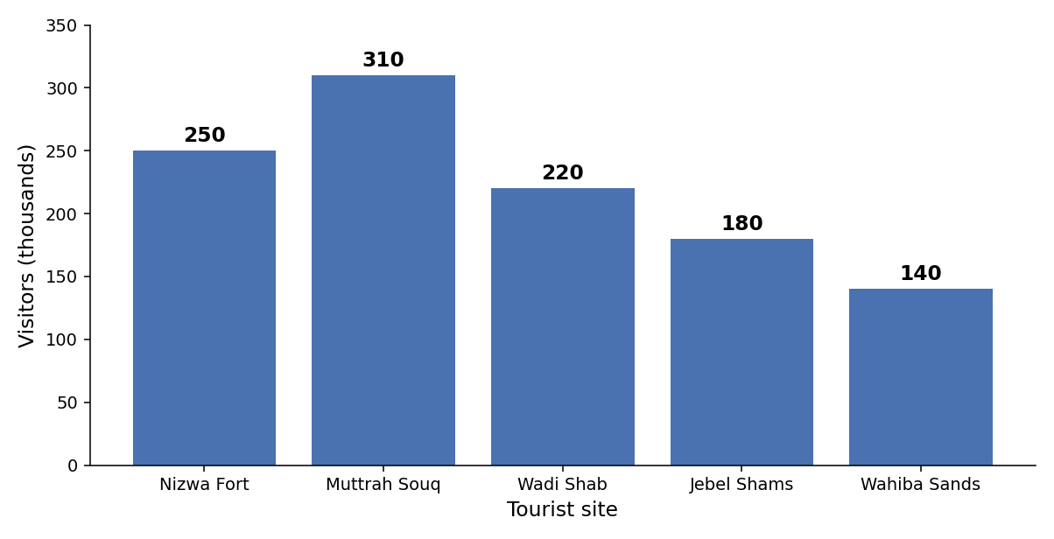
Number of visitors to tourist sites in Oman, 2025 (in thousands)

Your writing should be correct and organised.

WRITING 1 (continued)

 |  |  |  | Marker A | Marker B | Average

WRITING 2 (10 marks)
Complete the following task. Write at least 100 words.
Situation: You recently booked a one-week holiday with a travel company, but the holiday was very different from the promises on the company's website. The hotel was far from the beach, your room was old and noisy, and the guided tours were cancelled.

Task: Write a formal letter/ an email to the manager of the travel company, explaining the problems and asking for compensation.

Your writing should be clear and organised.

WRITING 2 (continued)

 |  |  |  | Marker A | Marker B | Average

WRITING
SCORE
WRITING  SCORE | 20

