ENGLISH LANGUAGE TEST
GRADE ELEVEN
Semester One
First Session
(Practice Exam - Theme 2: Those Teenage Things)

Name
School |  | Class

Write your answers on the Test Paper
Time: 2½ hours Pages: 14

ELEMENT |  | Marks |  | Red Marker | Green Marker | Blue Checker
 |  |  |  | Name | Name | Name
LISTENING | 20
READING | 20
WRITING 1 | 10
WRITING 2 | 10
TOTAL | 60
Prepared by Mohamed Mostafa Al Shorbagy, Regional Supervisor, Wusta Governorate
LISTENING 1 (Items 1-10) (10 marks)
You are going to hear a conversation between two students, Khalid and Muna.
Task One: Listen, and shade in the bubble next to the correct option.

1. | Why does Khalid look upset?
 |  | He failed an exam |  | His friend ignores him |  | He lost his phone
2. | Who are Saif's new friends?
 |  | boys from Grade Twelve |  | boys from another school |  | a school team
3. | How did Saif reply to Khalid's long message?
 |  | with one word |  | with a long letter |  | with a photo
4. | Where did Khalid see Saif yesterday?
 |  | in the library |  | in the cafeteria |  | at the sports hall
5. | What did Muna's cousin do last year?
 |  | joined a club |  | changed schools |  | wrote a letter
6. | When does the basketball team practise?
 |  | Sunday and Wednesday |  | Tuesday and Thursday |  | every day

Task Two: For each item, shade in the bubble to indicate whether the statement is True/False.
 | Statements | True | False
7. | Saif replies to Khalid's messages with long answers.
8. | Muna's cousin won a prize for her photos.
9. | The coach asked Khalid to join the team a month ago.
10. | Muna advises Khalid to end the friendship with anger.

LISTENING 2 (Items11-20) (10 marks)
You are going to hear a student telling her class about an important experience.
Part One: For each item, write a short answer (not more than FOUR WORDS).

11. What is Munira's father's job?

________________________________________________

12. Where did Munira keep her sketchbook?

___________________________________________________

13. Who sent photos of Munira's designs to Muscat?

___________________________________________________

14. What did the designer write on the last page?

__________________________________________________

15. Which dress made her father's eyes wet?

__________________________________________________

16. What prize did Munira's designs win?

_________________________________________________

Part Two: For each item, completer the missing words (not more than three words).
17. Munira's father wanted her to follow him into ____________.
18. She won the school's ____________ prize twice.
19. The visitor at the Career Fair was a designer from ____________.
20. The framed letter hangs next to her father's ____________.

LISTENING
SCORE
LISTENING  SCORE | 20
READING 1 (Items 1-10) (10 marks)
Read the following Text. Then complete the tasks.
Pick up any newspaper or watch any comedy programme, and you will meet him: the typical teenager. He is selfish and lazy, he thinks he knows everything, he cannot communicate with his parents, and he spends half the day in bed. But how true is this stereotype of young people in Oman today?
Supporters of the stereotype can point to real evidence. Walk through any mall and you will see groups of teenagers staring at their phones, silent in the middle of a crowd. Ask any teacher about homework, and you will hear the same stories of forgotten books and copied answers. Parents complain that their children change from friendly kids into strangers who answer every question with one word: 'fine'. And every family seems to have a teenager who treats his bedroom like a hotel room, appearing only at mealtimes.
However, the other side of the picture is rarely shown. This year, thousands of Omani teenagers volunteered in hospitals, cleaned beaches, visited old people's homes and coached younger children in sports. In international school competitions, Omani students regularly win prizes for science and programming. Some teenagers even run small online businesses before they finish school, designing websites, selling handmade crafts or managing social media pages for local shops. And in many families, teenagers care for younger brothers and sisters every afternoon while both parents are at work.
So why does the negative picture survive? Partly because it is funny - a lazy teenager makes a better joke than a hardworking one. Partly because bad news travels faster than good news: one rude teenager in a shop is remembered, while a hundred polite ones are forgotten. And partly because every generation forgets its own youth. The grandparents who criticise today's teenagers were once criticised themselves for their music, their clothes and their 'wasted' hours at coffee shops. Their own parents called them lazy and disrespectful, exactly the same words used today.

READING 1 (continued)

In my view, the stereotype tells us more about adults than about teenagers. Young people have always needed time to grow, freedom to make mistakes and adults who listen before they judge. Schools and families both have a role in this. If we expect the worst from teenagers, we should not be surprised when they stop trying to impress us. Expect the best, and most of them will prove you right, just as you once proved your own parents wrong.

Task One: For each item, write a short answer (not more than FOUR WORDS).

1. According to the stereotype, where does the teenager spend half the day?
__________________________________________________
2. What do teenagers in the mall stare at?
___________________________________________________
3. How do teenagers answer their parents' questions?
__________________________________________________
4. Where did thousands of Omani teenagers volunteer?
___________________________________________________
5. What did grandparents once get criticised for?
___________________________________________________
6. Who does the stereotype really describe, in the writer's view?
___________________________________________________

Task Two: For each item, shade in the bubble to indicate whether the statement is True/False.
 | Statements | True | False
7. | Supporters of the stereotype say teenagers communicate well with parents.
8. | Omani students regularly win prizes in science and programming.
9. | Good news travels faster than bad news, according to the writer.
10. | The writer advises adults to listen before they judge.

READING 2 (Items 11-20) (10 marks)
Read the text. Then complete the tasks.

During adolescence, a teenager's relationship with his or her parents changes. What was once a simple, comfortable relationship can become a daily argument about clothes, friends, phones and bedtimes. This happens in every country in the world, in every culture, and it is completely normal.
The main cause of conflict is independence. Teenagers want to make their own decisions: what to wear, who to see, when to sleep. Parents, however, still see them as children who need protection. Both sides want the best, but they want it in different ways, and so the daily arguments begin.
Sleep is another common battlefield. Many teenagers chat online or watch videos until two or three in the morning, then fall asleep in class the next day. Teachers complain, marks drop, and parents become angry. Doctors add that teenagers need eight to ten hours of sleep every night for their growing brains. It is a circle that is easy to start and very hard to stop.
Friends are a third area of disagreement. Parents sometimes do not like their teenager's friends. They worry about peer pressure and bad habits, so they ask questions like 'Who is this boy? What do his parents do?' The teenager, meanwhile, feels that his parents do not trust him.

READING 2 (continued)

The good news is that communication solves most of these problems. Do not wait for a big fight. Talk to your parents early, when everyone is calm, and listen to their side too. Choose the right moment - not when they are tired, busy or driving - and stay polite even when you disagree.
Responsibility also matters. If you finish your homework on time and come home when you promised, your parents will trust you more and give you more freedom. Trust is not a gift; it is something you earn, day after day, through small actions like telling the truth about where you are going and who you are meeting. And remember that your parents were teenagers once: their advice may sound old-fashioned, but it usually comes from love, not from a wish to control you.
Parents, too, can help. Give your teenagers space to grow, and be interested in their world - their music, their games, their friends - without judging everything they do. Adolescence is a short season of life. Families that keep talking and keep respecting each other come out of it stronger and closer than before.

Task One: shade in the bubble next to the correct option.

11. | What is the main cause of conflict between teenagers and parents?
 |  | independence |  | money |  | school marks
12. | Why do many students fall asleep in class?
 |  | they study all night |  | they sleep too late |  | they wake up early
13. | The word 'battlefield' in paragraph 3 is closest in meaning to:
 |  | place of fighting |  | place of sleeping |  | place of learning
14. | The word 'earn' in paragraph 6 is closest in meaning to:
 |  | win |  | buy |  | lose
15. | When is the best moment to talk to parents?
 |  | when they are driving |  | when everyone is calm |  | late at night
16. | What is the writer's advice to parents?
 |  | control everything |  | judge their friends |  | give them space

Task Two: Match the four paragraphs on the left with the main ideas in the box. (There are three extra ideas in the box.)

17. | Paragraph 2 | ___ | A. | the causes of disagreement
18. | Paragraph 3 | ___ | B. | the effects of late nights
19. | Paragraph 5 | ___ | C. | how to choose good friends
20. | Paragraph 7 | ___ | D. | talking solves problems
 |  |  | E. | the history of adolescence
 |  |  | F. | advice for parents as well
 |  |  | G | teenagers' favourite websites

READING
SCORE
READING  SCORE | 20

WRITING 1 (10 marks) Write an informative text of at least 100 words. Use ALL the information in the graph/figure.
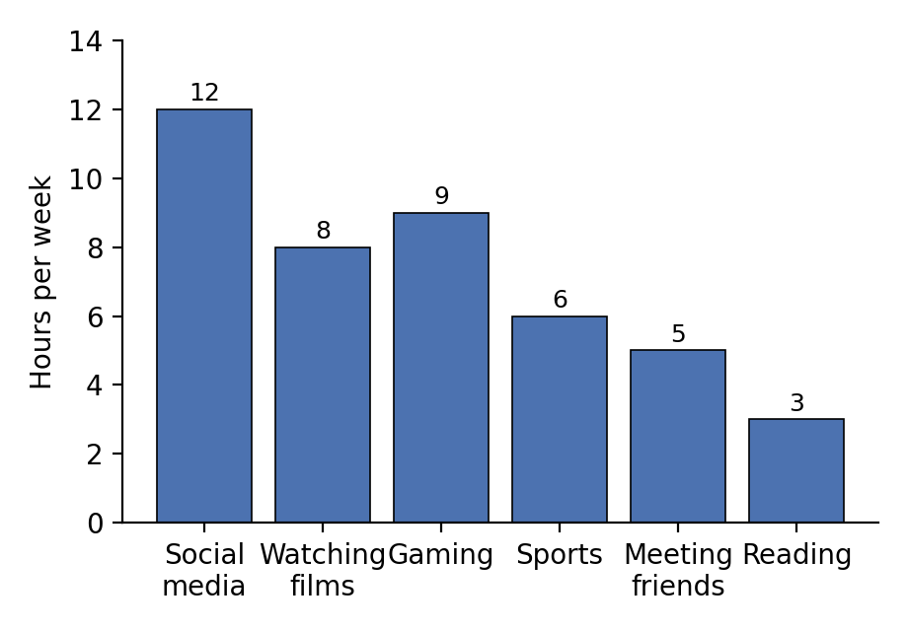
How teenagers in Oman spend their free time (hours per week)

Your writing should be correct and organised.

WRITING 1 (continued)

 |  |  |  | Marker A | Marker B | Average

WRITING 2 (10 marks)
Complete the following task. Write at least 100 words.
Situation: Your local council has announced that it wants to improve facilities for young people in your town, and it has invited residents to send their suggestions.

Task: Write a formal letter/ an email to the council, giving your suggestions and explaining why they would help teenagers.

Your writing should be clear and organised.

WRITING 2 (continued)

 |  |  |  | Marker A | Marker B | Average

WRITING
SCORE
WRITING  SCORE | 20

