ENGLISH LANGUAGE TEST
GRADE ELEVEN
Semester One
First Session
(Practice Exam - Theme 1: Communication)

Name
School |  | Class

Write your answers on the Test Paper
Time: 2½ hours Pages: 14

ELEMENT |  | Marks |  | Red Marker | Green Marker | Blue Checker
 |  |  |  | Name | Name | Name
LISTENING | 20
READING | 20
WRITING 1 | 10
WRITING 2 | 10
TOTAL | 60
Prepared by Mohamed Mostafa Al Shorbagy, Regional Supervisor, Wusta Governorate
LISTENING 1 (Items 1-10) (10 marks)
You are going to hear a conversation between two students, Salim and Aisha.
Task One: Listen, and shade in the bubble next to the correct option.

1. | What does Aisha want to write about?
 |  | websites |  | body language |  | job interviews
2. | Why couldn't Salim look at the audience?
 |  | He was too nervous |  | He was too bored |  | He forgot his notes
3. | When did Aisha download the articles?
 |  | this morning |  | last week |  | last night
4. | How will Aisha send the articles?
 |  | by email |  | by messaging app |  | on a memory stick
5. | When will they meet in the library?
 |  | on Thursday |  | on Tuesday |  | on Wednesday
6. | What example does Aisha give about tone of voice?
 |  | the word 'fine' |  | a famous speech |  | a phone call

Task Two: For each item, shade in the bubble to indicate whether the statement is True/False.
 | Statements | True | False
7. | Aisha thinks websites are more interesting than body language.
8. | The class asked Salim many questions at the end of his presentation.
9. | Salim and Aisha will watch the video before comparing their notes.
10. | The video about listening skills lasts twenty minutes.

LISTENING 2 (Items11-20) (10 marks)
You are going to hear a student telling his class about an important experience.
Part One: For each item, write a short answer (not more than FOUR WORDS).

11. Who announced the competition?

________________________________________________

12. Whose advice did Yusuf remember on stage?

___________________________________________________

13. What was Yusuf's speech about?

___________________________________________________

14. How long did he practise every night?

__________________________________________________

15. Where was Yusuf's sister sitting?

__________________________________________________

16. What was Yusuf's final position?

_________________________________________________

Part Two: For each item, completer the missing words (not more than three words).
17. Yusuf used to be the ____________ student in his class.
18. He practised in front of his bedroom ____________.
19. Forty students from ____________ schools gathered in the hall.
20. Communication is about connection, not ____________.

LISTENING
SCORE
LISTENING  SCORE | 20
READING 1 (Items 1-10) (10 marks)
Read the following Text. Then complete the tasks.
For most of human history, communication was slow. A letter from Muscat to London could take a month. Today, a video call connects the same two cities in a second. But is faster always better? People disagree about what modern communication is doing to us.
Supporters of modern communication point to amazing benefits. Families separated by work or study can see each other's faces every day. A student in Salalah can attend an online lesson taught in Muscat. Businesses make decisions in hours, not weeks. Doctors can examine patients who live far from hospitals, and a farmer in the mountains can sell his dates to a customer in another continent. During the recent school closure, thousands of Omani children continued their education through video lessons. For young people especially, messaging is not a cold, robotic activity: it is how they maintain friendships, share jokes and support each other through difficult times. A kind message at midnight can mean as much as a visit.
Critics answer that quantity has replaced quality. We send hundreds of messages but say very little. Short forms and abbreviations damage spelling, and emojis replace real feelings. Worse, online communication is addictive: many teenagers check their phones a hundred times a day and feel anxious when they cannot. Some experts also blame messaging for weaker face-to-face skills. A generation that can chat online for hours may struggle with a simple job interview, where eye contact and a clear voice still decide who gets the job. Employers increasingly complain that young workers cannot write a formal letter or hold a telephone conversation. Real conversations are constantly replaced by notifications.
There is also the question of honesty. Behind a screen, people can pretend to be anyone. Trust, which once grew from eye contact and tone of voice, must now survive without either.

READING 1 (continued)

In my view, the tool is not the problem; the habit is. A smartphone can carry a loving message to a grandmother or an angry comment to a stranger. The technology simply does what we ask it to do. What we need is not less communication, but wiser communication: know when to type, when to call, and when to sit down, look someone in the eye, and talk. Schools can also help by teaching students when each kind of communication is appropriate. That simple choice, made every day, will decide whether our devices serve us or rule us.

Task One: For each item, write a short answer (not more than FOUR WORDS).

1. How long did a letter from Muscat to London take?
__________________________________________________
2. Who can examine patients far from hospitals?
___________________________________________________
3. What do critics say emojis replace?
__________________________________________________
4. How often do many teenagers check their phones?
___________________________________________________
5. What did trust once grow from?
___________________________________________________
6. What kind of communication does the writer want?
___________________________________________________

Task Two: For each item, shade in the bubble to indicate whether the statement is True/False.
 | Statements | True | False
7. | A student in Salalah can attend a lesson taught in Muscat.
8. | The writer believes smartphones are the main problem.
9. | Teenagers feel anxious when they cannot check their phones.
10. | The writer advises people to stop using technology.

READING 2 (Items 11-20) (10 marks)
Read the text. Then complete the tasks.

Twenty-five years ago, most families in Oman communicated by letter or by landline telephone. Sending a letter to another country took weeks, and international calls were expensive, so people thought carefully before they phoned abroad.
Everything changed with the arrival of the Internet in the late 1990s. At first, connections were slow and few homes had a computer. People went to Internet cafes to check their email. But year after year, the technology became faster and cheaper. A monthly Internet connection now costs less than a single international call once did.
Today, almost every family has a smartphone with a high-speed connection. Grandparents video-call their grandchildren in other countries for free. Students discuss homework in messaging groups, and teachers share files through online platforms. Shops advertise on social networking sites, and government services answer questions through official accounts. Even in remote mountain and desert villages, people are now connected to the rest of the world. A message that once took weeks now arrives in a second.
However, this new world also has disadvantages. Many people spend hours looking at screens instead of talking to the person sitting next to them. Families sometimes sit together in silence, each person busy with a different screen. Friends argue because a short message sounded colder than it was meant to be. Grandparents sometimes complain that family gatherings have become silent events.

READING 2 (continued)

Experts also warn that young people sometimes find face-to-face conversation difficult. Online messages can be misunderstood because they have no tone of voice or body language. Teachers notice that students find it harder to concentrate on a long book.
Privacy is another concern. Photos and messages shared online can stay on the Internet forever, so users must think before they post. Once a photo is posted, deleting it completely is almost impossible. Schools now teach online safety as part of the curriculum, and parents are advised to learn the same apps their children use. Children copy what they see, so adults must model good habits themselves.
In my view, the answer is balance. We should use technology to connect with people far away, but we should never forget the value of a real conversation: eye contact, a warm voice and a genuine smile. Some families now have a simple rule: no phones at the dinner table. It brings back the sound of real conversation. The technology will keep changing, but good manners do not have to.

Task One: shade in the bubble next to the correct option.

11. | Why did people think carefully before phoning abroad?
 |  | calls cost a lot |  | phones were rare |  | lines were busy
12. | Where did people first go to check their email?
 |  | libraries |  | Internet cafes |  | post offices
13. | The word 'concern' in paragraph 6 is closest in meaning to:
 |  | rule |  | worry |  | subject
14. | The word 'balance' in the last paragraph is closest in meaning to:
 |  | a fair mix |  | a fast connection |  | a new rule
15. | What do schools now teach as part of the curriculum?
 |  | online safety |  | letter writing |  | programming
16. | What rule do some families have?
 |  | no phones at dinner |  | no calls after eight |  | one hour of Internet

Task Two: Match the four paragraphs on the left with the main ideas in the box. (There are three extra ideas in the box.)

17. | Paragraph 2 | ___ | A. | the early days of the Internet in Oman
18. | Paragraph 3 | ___ | B. | communication in Oman today
19. | Paragraph 4 | ___ | C. | the problems of screen time
20. | Paragraph 6 | ___ | D. | the history of the landline
 |  |  | E. | how to make international calls
 |  |  | F. | privacy and online safety
 |  |  | G | the writer's advice for families

READING
SCORE
READING  SCORE | 20

WRITING 1 (10 marks) Write an informative text of at least 100 words. Use ALL the information in the graph/figure.
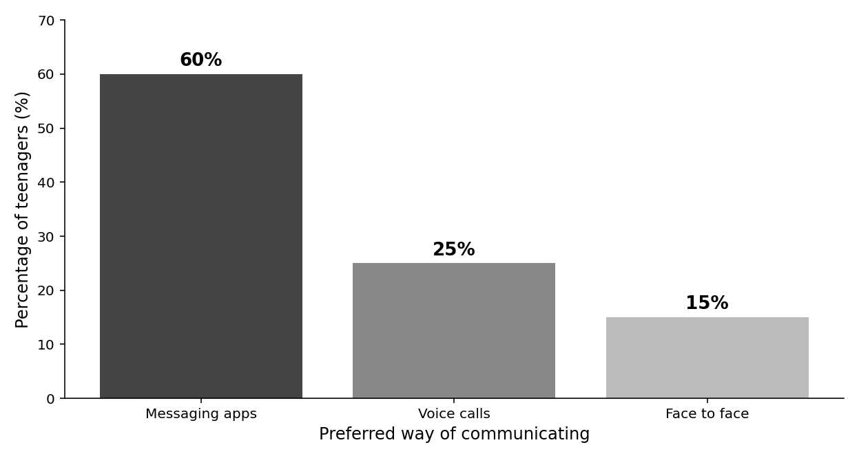
How Omani teenagers prefer to communicate with friends

Your writing should be correct and organised.

WRITING 1 (continued)

 |  |  |  | Marker A | Marker B | Average

WRITING 2 (10 marks)
Complete the following task. Write at least 100 words.
Situation: You have read an article in a local newspaper which says that smartphones are destroying young people's social skills. You have decided to write to the newspaper.

Task: Write a formal letter/ an email to the editor, giving your opinion about this idea.

Your writing should be clear and organised.

WRITING 2 (continued)

 |  |  |  | Marker A | Marker B | Average

WRITING
SCORE
WRITING  SCORE | 20

