

ENGLISH LANGUAGE TEST
GRADE TEN
Academic Year -2026/2027
Semester One _ First Session
(Practice Exam - Unit 4: Civilisation)

Name
School |  | Class

Write your answers on the Test Paper Total Marks: 60
Time: 2½ hours Pages: 14

ELEMENT |  | Marks |  | Signature with Name
 |  | In Numbers | In Words | First Marker | Second Marker
LISTENING | 15
VOCABULARY | 5
GRAMMAR | 5
READING | 20
WRITING | 15
TOTAL | 60
Prepared by Mohamed Mostafa Al Shorbagy, Regional Supervisor, Wusta Governorate
LISTENING 1 (Items 1-7) (7 marks)
You are going to hear a conversation between a student, Hamad, and his grandmother.
Listen, and shade in the bubble next to the correct option.

1. | Which fort is Hamad writing about?
 |  | Bahla Fort |  | Nizwa Fort |  | Jalali Fort
2. | When was the fort built?
 |  | in the sixteenth century |  | in the seventeenth century |  | in the eighteenth century
3. | Who took Hamad's grandmother to the fort?
 |  | her father |  | her teacher |  | her husband
4. | What happened to the fort in 1990?
 |  | It was restored completely |  | It was destroyed completely |  | It was opened to tourists
5. | Which product was sold in Nizwa's old market?
 |  | gold |  | rice |  | frankincense
6. | Where are the grandmother's photos kept?
 |  | in a cupboard |  | in a museum |  | in a box under her bed
7. | When will Hamad give his presentation?
 |  | on Friday |  | on Saturday |  | on Sunday

LISTENING 2 (Items 8-15) (8 marks)
You are going to hear a talk about ancient civilisations in Oman.
Task One: Listen and for each item, write a short answer (not more than FOUR WORDS or a NUMBER).

8. What was the ancient civilisation of Majan famous for?
__________________________________________________
9. Where does the frankincense tree grow in Oman?
___________________________________________________
10. When was the Frankincense Trail added to the World Heritage List?
___________________________________________________
11. What were the Omani wooden ships called?
_________________________________________________

Task Two: Listen For each item, shade in the bubble next to the correct option.

 | Statements | True | False
12. | Omani copper was traded only inside Oman.
13. | Camel caravans carried frankincense across the desert.
14. | Omani sailors never travelled further than India.
15. | Stone tombs at Bat are more than four thousand years old.

LISTENING
SCORE
LISTENING  SCORE | 15

VOCABULARY (Items 1-5) (5 marks)
For each item, shade in the bubble next to the correct option.
Last summer, we visited an old (1) ______ near Muscat. It was built three hundred years ago. Inside, we saw old (2) ______ that sailors used to find their way across the sea. In one room, a small shop sold (3) ______ , the famous resin once traded across the world. The site gives us (4) ______ of how people lived long ago. It was an amazing day. I learnt a lot about our country's (5) ______ and its great sailors.

1.
 |  | fort |  | factory |  | farm |  | flat
2.
 |  | maps |  | magazines |  | mirrors |  | motors
3.
 |  | plastic |  | frankincense |  | electricity |  | furniture
4.
 |  | problems |  | evidence |  | poverty |  | promises
5.
 |  | history |  | weather |  | economy |  | technology

VOCABULARY
SCORE
VOCABULARY  SCORE | 5

GRAMMAR (Items 1–5) (5 marks)
For each item, shade in the bubble under the correct option.
Speaker A: | Hi Mariam. Have you started your history project?
Speaker B: | Yes! I'm writing about Bat. Its stone tombs (1) was / were ___________ built four thousand years ago.
Speaker A: | I read that Omani copper (2) was / were ___________ traded to Mesopotamia by sea.
Speaker B: | That's right. The first dhows (3) was / were ___________ made of wood, without any metal nails.
Speaker A: | I also learnt that frankincense (4) was / were ___________ carried across the desert by camel caravans.
Speaker B: | These discoveries (5) was / were ___________ studied by archaeologists from many countries.
Speaker A: | Exactly. Our past is full of treasures. Let's visit Bat together!

GRAMMAR
SCORE
GRAMMAR  SCORE | 5

READING 1 (Items 1-10) (10 marks)
Read the text. Then, complete the tasks.
When sixteen-year-old Salim Al Balushi joined his uncle's archaeology team for a week in the summer, he expected quiet days of brushing dust off old stones. Instead, he had the adventure of his life.
The team was working near Bat, in the Al Hajar mountains, where stone tombs were built more than four thousand years ago. On his first morning, the site director, Dr Fatma, gave Salim a small brush and a pair of gloves. "Be patient," she told him. "History does not like to be hurried." Salim was given a square of earth two metres wide, and he spent the whole day removing sand a few centimetres at a time.
On Tuesday, something hard appeared under his brush. Salim's heart jumped. He called Dr Fatma, who knelt beside him and smiled. Together they uncovered a small clay pot, complete and unbroken. Inside it were twelve small copper beads. "This pot was made by a person who lived four thousand years ago," Dr Fatma said quietly. "You are the first person to touch it since then."
The find was recorded carefully. Photographs were taken, the pot was placed in a special box, and the beads were sent to the laboratory in Muscat to be studied. That evening, the team sat around the fire and talked about the people of Bat: farmers, builders and traders whose copper was carried by ship to distant lands.
At the end of the week, the team held a small ceremony. Salim was given a certificate and, to his surprise, the honour of naming the pot. He chose the name "Umm al-Kanz", Mother of the Treasure. The whole team laughed and agreed.
Back home in Muscat, Salim could not stop talking about Bat. His father listened proudly, and his teachers asked him to speak to the whole school. Then Salim wrote about his week for the school magazine. "People think archaeology is about things," he wrote. "Now I know it is about people. Every pot was made by hands like ours, and every bead was chosen with care. When I held that pot, I shook hands with the past." Next summer, Salim plans to return to Bat - and this time, his little sister wants to come too.

READING 1 (continued)
Task One: for each item, shade in the bubble next to the correct option.

1. | What did Salim expect before joining the team?
 |  | big adventures |  |  | quiet dusty days |  |  |  | long sea journeys
2. | What did Dr Fatma give Salim on the first morning?
 |  | a brush and gloves |  |  | a map and a camera |  |  |  | a spade and a lamp
3. | What did Salim find on Tuesday?
 |  | a gold coin |  |  |  | a clay pot |  |  |  | a stone tomb

4. | What was inside the pot?
 |  | twelve copper beads |  | dried dates |  | old coins
5. | Where were the beads sent to be studied?
 |  | to the museum in Nizwa |  | to a university abroad |  | to the laboratory in Muscat
6. | What name did Salim give the pot?
 |  | Mother of the Treasure |  | The King's Cup |  | Bat's Gift

Task Two: For each item, completer the missing words (not more than two words).
7. Salim joined his uncle's team in the _______________ holidays.
8. The pot he found was made of _______________ .
9. In the evening, the team sat around the _______________ and talked.
10. Salim wrote about his week for the school _______________ .

READING 2 (Items 11-20) (10 marks)
Read the text. Then, complete the tasks.

Oman is full of history. Its forts, tombs and old towns tell the story of thousands of years of civilisation. But preserving the past costs money. Should Oman spend more on protecting its heritage, or should that money go to new roads, schools and hospitals? People disagree strongly.
Those who support preservation give strong reasons. First, heritage is irreplaceable: once an old fort is destroyed, no money can bring it back. Second, old sites attract tourists, and tourists bring money. The restored forts of Nizwa and Bahla welcome hundreds of thousands of visitors every year, and each visitor supports hotels, restaurants and guides. Third, heritage builds identity. Children who visit ancient sites learn to be proud of their country and to respect the achievements of earlier generations.
Those who disagree also have a case. Restoration is expensive: repairing one large fort can cost millions of rials, money that could build a new school or clinic. They also argue that many sites are rarely visited. Some ruins stand empty in remote places, guarded but ignored, while young families in the cities wait for better services. Old stones, they say, do not fill empty stomachs or cure the sick. In their view, a country must look after the living before the dead.
The modern world, they add, has its own needs. New museums with interactive screens teach history better than dusty ruins, and digital copies can preserve a monument's image forever, even if the real stones fall. A scanned fort can be explored online by every student in the country, without a single rial spent on guards, repairs or car parks. Why spend fortunes on old walls when the future needs investment?

READING 2 (continued)

In my opinion, this is not a real choice, because heritage pays for itself. A preserved fort is not a cost; it is an investment that returns tourists, jobs and pride for centuries. The question is not whether to protect our heritage, but how to do it wisely.
The stones of Bat have waited four thousand years; they can teach us for four thousand more, if we let them. Nations that forget their past lose their way, while nations that honour it grow stronger and prouder. Children should grow up knowing the story written in their own land, walking the same forts their ancestors built. Oman should make sure they can read that story, page by page, stone by stone.

Task One: For each item, write a short answer (not more than FOUR WORDS or a NUMBER).

11. According to the writer, what can no money bring back?

__________________________________

12. Name one place mentioned that welcomes many visitors.

___________________________________

13. What do children learn at ancient sites, besides pride?

___________________________________

14. What can teach history better than dusty ruins, according to critics?

___________________________________

15. What can preserve a monument's image forever?

___________________________________

16. What have the stones of Bat waited for?

___________________________________
Task Two: For each item, shade in the bubble to indicate whether the statement is True/False.
 | Statements | True | False
17. | Restoring a large fort is cheap.
18. | Some ruins are rarely visited.
19. | The writer believes heritage and progress cannot exist together.
20. | The writer thinks nations should remember their past.

READING
SCORE
READING  SCORE | 20

WRITING 1 (5 marks)
Write a text including all the information in the graph/figure below. Write at least 80 words.
"Grade 10 Students' Favourite Historical Places to Visit"
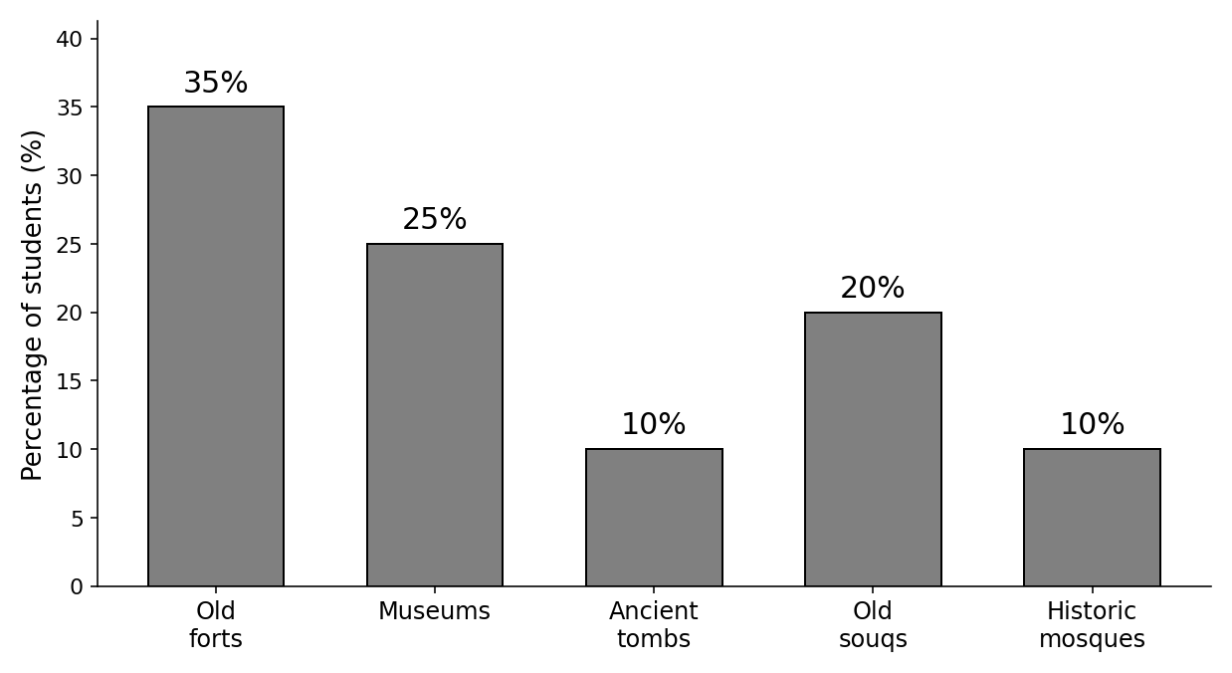

Your writing should be clear and well-organised.

WRITING 1 (continued)

Marker A | Marker B | Average |  | (___________________________)
 |  |  |  | (___________________________) | 5

WRITING 2 (10 marks)
Complete the following narrative writing task. Write at least 100 words.
You recently visited a historical place in Oman with your family or your class. Write a story about your visit: what you saw, what happened there, and what you learnt.

Your writing should be clear and interesting.

WRITING 2 (continued)

Marker A | Marker B | Average |  | (___________________________)
 |  |  |  | (___________________________) | 10

