

ENGLISH LANGUAGE TEST
GRADE TEN
Academic Year -2026/2027
Semester One _ First Session
(Practice Exam - Unit 3: Renewable Energy)

Name
School |  | Class

Write your answers on the Test Paper Total Marks: 60
Time: 2½ hours Pages: 14

ELEMENT |  | Marks |  | Signature with Name
 |  | In Numbers | In Words | First Marker | Second Marker
LISTENING | 15
VOCABULARY | 5
GRAMMAR | 5
READING | 20
WRITING | 15
TOTAL | 60
Prepared by Mohamed Mostafa Al Shorbagy, Regional Supervisor, Wusta Governorate
LISTENING 1 (Items 1-7) (7 marks)
You are going to hear a conversation between two students, Khalid and Reem.
Listen, and shade in the bubble next to the correct option.

1. | What does Reem want to build?
 |  | a water heater |  | a solar-powered fan |  | a wind turbine
2. | Why do solar panels work well in Oman?
 |  | there is sunlight all year |  | they are very cheap |  | they are easy to carry
3. | How much did the solar panel cost?
 |  | two rials |  | twelve rials |  | twenty rials
4. | When will the panel arrive?
 |  | on Thursday |  | on Saturday |  | on Tuesday
5. | Where will they meet on Saturday?
 |  | in the library |  | in the science lab |  | in the classroom
6. | Who helped last year's winners?
 |  | Mr Adel |  | Reem's father |  | the headteacher
7. | What will Khalid make tonight?
 |  | a poster |  | the slides |  | the motor

LISTENING 2 (Items 8-15) (8 marks)
You are going to hear a talk about renewable energy in Oman.
Task One: Listen and for each item, write a short answer (not more than FOUR WORDS or a NUMBER).

8. What is most electricity in Oman made from today?
__________________________________________________
9. When did Oman open its first large solar power plant?
___________________________________________________
10. Where do strong winds blow in Oman?
___________________________________________________
11. What can solar panels not do at night?
_________________________________________________

Task Two: Listen For each item, shade in the bubble next to the correct option.

 | Statements | True | False
12. | Oil and gas are renewable energy sources.
13. | Oman is a good place for solar energy.
14. | Wind farms in the south produce electricity for local towns.
15. | The speaker thinks Oman should stop using solar power.

LISTENING
SCORE
LISTENING  SCORE | 15

VOCABULARY (Items 1-5) (5 marks)
For each item, shade in the bubble next to the correct option.
Our school team designed a small reading lamp for the science fair. The lamp uses (1) ______ energy from the sun. We placed a panel near the window so it could (2) ______ electricity during the day. The main (3) ______ of the lamp is that it does not need batteries, so it is very cheap to use. Some plastic lamps are (4) ______ to the environment, but ours is clean and safe. We hope our (5) ______ will help students in villages that have no electricity at night.

1.
 |  | solar |  | nuclear |  | chemical |  | kinetic
2.
 |  | waste |  | generate |  | burn |  | install
3.
 |  | disadvantage |  | advantage |  | solution |  | problem
4.
 |  | helpful |  | useful |  | harmful |  | peaceful
5.
 |  | invention |  | power plant |  | oilfield |  | steam

VOCABULARY
SCORE
VOCABULARY  SCORE | 5

GRAMMAR (Items 1–5) (5 marks)
For each item, shade in the bubble under the correct option.
Speaker A: | Hi Salma. Have you finished your project about renewable energy?
Speaker B: | Almost! Solar panels are much cheaper now. (1) Moreover, / But ___________ they work well in sunny Oman.
Speaker A: | Good point. Wind energy is also clean and free. (2) In addition, / However, ___________ the wind in our area changes all the time.
Speaker B: | True. Solar energy is free, (3) but / moreover ___________ it is not available at night.
Speaker A: | Wind turbines are noisy. Solar panels, (4) moreover, / on the other hand, ___________ are silent.
Speaker B: | Right. Solar panels are safe for birds. (5) Also, / However, ___________ they need very little water.
Speaker A: | Excellent points. Let's present both types fairly at the science fair on Sunday morning.

GRAMMAR
SCORE
GRAMMAR  SCORE | 5

READING 1 (Items 1-10) (10 marks)
Read the text. Then, complete the tasks.
Last month, fifteen-year-old Aisha Al Lawati entered the science fair at her school in Salalah. She wanted to build something useful, so she decided to make a small solar oven. Her physics teacher, Mr Adel, told her that the south of Oman has strong sunlight for most of the year. "Use that gift," he said with a smile.
Aisha collected the materials: a cardboard box, black paper, aluminium foil and a piece of glass. Her father helped her cut the box in the garage on Friday afternoon. She painted the inside black because dark colours take in more heat. Then she covered the sides with shiny foil to direct the sunlight into the box.
On the first test day, the oven failed completely. Aisha put an egg inside and waited for two hours, but the egg stayed cold. She felt terrible, but she did not give up. That evening, she watched three videos about solar ovens and discovered her mistake: the glass cover was too small, so the heat escaped.
The next morning, Aisha went to the market with her mother and bought a larger piece of glass for two rials. She sealed the edges carefully with tape. This time, she tested the oven at twelve o'clock, when the sun was strongest. After only forty minutes, the egg was cooked! Her little brother was so surprised that he called all the neighbours to see it.
At the science fair, forty students from six schools showed their projects in the main hall. The judges tasted food from Aisha's oven and asked her many questions. She explained that solar ovens could help families in mountain villages where electricity is expensive. One judge called it "a small idea with a big heart". When the headteacher announced the results, Aisha won second prize: a certificate and a book about Omani inventions.
Aisha was delighted, but she has bigger plans. Next month, she will build a larger oven that can cook rice for the whole family. "The sun gives us free energy every day," she told the school magazine. "We just have to learn how to use it." Her plan is to test the new oven during the winter holiday.

READING 1 (continued)
Task One: for each item, shade in the bubble next to the correct option.

1. | What did Aisha decide to build?
 |  | a water heater |  |  | a solar oven |  |  |  | a solar fan
2. | Why did she paint the inside black?
 |  | to look beautiful |  |  | to take in more heat |  |  |  | to keep it clean
3. | What happened on the first test day?
 |  | The egg stayed cold |  |  |  | The box caught fire |  |  |  | The glass broke

4. | What was Aisha's mistake?
 |  | The foil was old |  | The box was too small |  | The glass cover was too small
5. | When did she test the oven the second time?
 |  | at twelve o'clock |  | in the evening |  | early in the morning
6. | What prize did Aisha win?
 |  | first prize |  | second prize |  | third prize

Task Two: For each item, completer the missing words (not more than two words).
7. Aisha covered the sides of the box with shiny _______________ .
8. On the first test day, the egg stayed _______________ .
9. She bought a larger piece of glass for two _______________ .
10. Next month, Aisha will build an oven that can cook _______________ .

READING 2 (Items 11-20) (10 marks)
Read the text. Then, complete the tasks.

In the deserts of Oman, the sun shines almost every day of the year. To many experts, this is not just good weather; it is free energy waiting to be used. But should Oman invest billions in solar and wind power, or stay with the oil and gas it knows so well? The debate divides many people.
Supporters of renewable energy point to clear advantages. First, sunlight and wind are unlimited: oil will run out one day, but the sun will keep shining. Second, renewable energy is clean. A solar power plant produces electricity without smoke, so the air stays fresh and children grow up healthier. Third, the technology gets cheaper every year, so the price argument is becoming weaker. Finally, new energy projects create jobs. When Oman built its first large solar plant, hundreds of young engineers and technicians found work, and many learnt skills they can use for the rest of their lives.
Critics, however, see real problems. The biggest one is cost: solar panels and wind turbines are expensive to install, even if the energy they produce later is free. They also point out that renewable power is unreliable. The sun does not shine at night, and the wind does not always blow, so solar farms need huge batteries, which cost even more money. A wind farm in the south of Oman, for example, needed years of planning before the first turbine turned. In addition, some people worry that large solar farms take land away from farms and wildlife.
Oil and gas, they add, are reliable and already paid for. Power plants exist, workers are trained, and the system works day and night. Change is also hard for workers: thousands of families depend on oil jobs, and they need time to learn new skills. Why replace something that is not broken?

READING 2 (continued)

In my opinion, this is a false choice. Oman does not have to abandon oil tomorrow, but it cannot ignore the future either. The wisest path is gradual change: keep using gas where we must, but invest seriously in solar and wind where we can. Every solar panel installed today means more oil saved for tomorrow.
The desert sun helped Oman grow frankincense in the past; tomorrow it can power our schools and hospitals. Nations that prepare early for change always win, and schools should teach children about clean energy from a young age. Oman should be one of them.

Task One: For each item, write a short answer (not more than FOUR WORDS or a NUMBER).

11. What is free energy waiting to be used, according to experts?

__________________________________

12. Name one unlimited energy source mentioned.

___________________________________

13. What stays fresh because solar plants make no smoke?

___________________________________

14. What do solar farms need because nights are dark?

___________________________________

15. What may solar farms take away from farms and wildlife?

___________________________________

16. Which crop grew in Oman with the desert sun in the past?

___________________________________
Task Two: For each item, shade in the bubble to indicate whether the statement is True/False.
 | Statements | True | False
17. | Oil will never run out.
18. | Oman's first large solar plant gave work to young engineers.
19. | Renewable power is always available day and night.
20. | The writer wants Oman to stop using oil immediately.

READING
SCORE
READING  SCORE | 20

WRITING 1 (5 marks)
Write a text including all the information in the graph/figure below. Write at least 80 words.
"Grade 10 Students' Favourite Renewable Energy Sources"
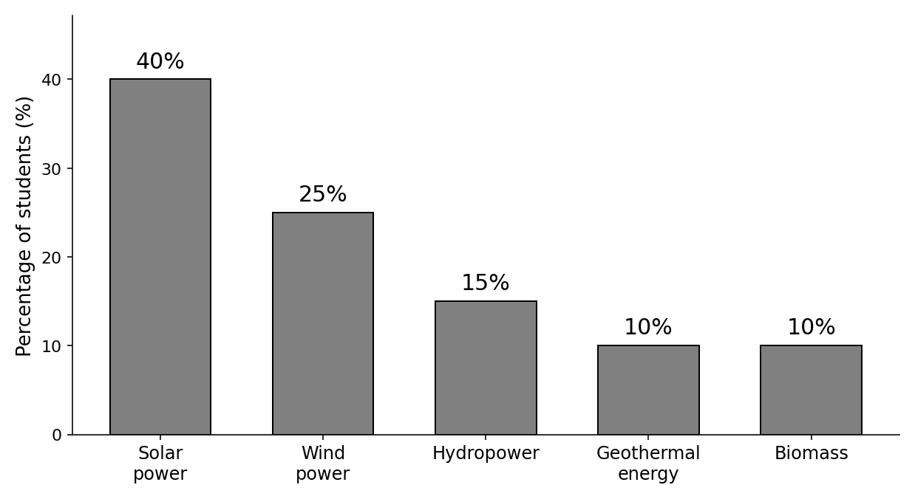

Your writing should be clear and well-organised.

WRITING 1 (continued)

Marker A | Marker B | Average |  | (___________________________)
 |  |  |  | (___________________________) | 5

WRITING 2 (10 marks)
Complete the following narrative writing task. Write at least 100 words.
You were presenting your science project about renewable energy when something unexpected happened. Write a story about what happened and how you dealt with it.

Your writing should be clear and interesting.

WRITING 2 (continued)

Marker A | Marker B | Average |  | (___________________________)
 |  |  |  | (___________________________) | 10

