

ENGLISH LANGUAGE TEST
GRADE TEN
Academic Year -2026/2027
Semester One _ First Session
(Practice Exam - Unit 2: Climate Change)

Name
School |  | Class

Write your answers on the Test Paper Total Marks: 60
Time: 2½ hours Pages: 14

ELEMENT |  | Marks |  | Signature with Name
 |  | In Numbers | In Words | First Marker | Second Marker
LISTENING | 15
VOCABULARY | 5
GRAMMAR | 5
READING | 20
WRITING | 15
TOTAL | 60
Prepared by Mohamed Mostafa Al Shorbagy, Regional Supervisor, Wusta Governorate
LISTENING 1 (Items 1-7) (7 marks)
You are going to hear a conversation between two students, Salem and Mona.
Listen, and shade in the bubble next to the correct option.

1. | What is Salem drawing?
 |  | a poster |  | a map |  | a timetable
2. | When will classes bring old plastic bottles?
 |  | on Sunday |  | on Monday |  | on Wednesday
3. | Who will give a talk on Wednesday?
 |  | Mr Rashid |  | Ms Laura |  | the headteacher
4. | What did Salem's family switch to?
 |  | LED lights |  | solar panels |  | electric cars
5. | What will happen on Thursday?
 |  | a film show |  | a debate |  | a beach clean-up
6. | Who will judge the debate?
 |  | Ms Laura |  | Mr Rashid |  | Salem's uncle
7. | Where will the two students meet tomorrow?
 |  | in the library |  | in the media room |  | in the classroom

LISTENING 2 (Items 8-15) (8 marks)
You are going to hear a talk about the causes and effects of climate change.
Task One: Listen and for each item, write a short answer (not more than FOUR WORDS or a NUMBER).

8. What is the main reason for rising global temperatures?
__________________________________________________
9. What do cars and factories release into the atmosphere?
___________________________________________________
10. What is melting as a result of global warming?
___________________________________________________
11. What can we plant to help the planet?
_________________________________________________

Task Two: Listen For each item, shade in the bubble next to the correct option.

 | Statements | True | False
12. | Climate change is a short-term change in the weather.
13. | Some low islands may disappear because of the rising sea level.
14. | All countries now suffer from floods.
15. | The speaker believes small actions can make a big difference.

LISTENING
SCORE
LISTENING  SCORE | 15

VOCABULARY (Items 1-5) (5 marks)
For each item, shade in the bubble next to the correct option.
Our class wanted to make our school greener. First, we studied the (1) ______ caused by plastic cups near the playground. We found that most cups were (2) ______ items, used once and then thrown away. Our teacher suggested bringing (3) ______ bottles that we can use many times. We also learnt that leaving lights and computers on all day is a bad (4) ______. At the end of the project, every student signed a promise to (5) ______ the amount of waste they produce.

1.
 |  | pollution |  | population |  | tradition |  | competition
2.
 |  | reusable |  | single-use |  | eco-friendly |  | expensive
3.
 |  | reusable |  | dangerous |  | harmful |  | limited
4.
 |  | habitat |  | habit |  | hobby |  | holiday
5.
 |  | increase |  | reduce |  | release |  | rise

VOCABULARY
SCORE
VOCABULARY  SCORE | 5

GRAMMAR (Items 1–5) (5 marks)
For each item, shade in the bubble under the correct option.
Speaker A: | Hi Mariam. Did you watch the documentary film about polar bears yesterday evening?
Speaker B: | Yes! The sea ice near the North Pole is melting (1) because / because of ___________ global warming.
Speaker A: | I know. The planet is getting warmer every year (2) because of / because ___________ greenhouse gases.
Speaker B: | Many animals may lose their homes, (3) because / so ___________ we must act now.
Speaker A: | You're right. Our class uses less plastic this month. (4) As a result, / As a result of ___________ we produce less waste.
Speaker B: | Great! Small actions help, (5) but / so ___________ let's also ask the whole school to join Green Week.
Speaker A: | Good idea. I'll design a poster tonight and bring it to school tomorrow morning.

GRAMMAR
SCORE
GRAMMAR  SCORE | 5

READING 1 (Items 1-10) (10 marks)
Read the text. Then, complete the tasks.
Last term, fourteen-year-old Salim Al Harthy walked along the beach near his home in Sur and felt sad. The sand was covered with plastic bottles, bags and straws. Some bottles were old and grey; others were new and shiny. Among the bottles, he found a small turtle caught in a plastic bag. He freed it carefully and watched it move slowly back to the sea. That evening, Salim decided to do something.
The next day, he spoke to his science teacher, Ms Amal, and together they planned a beach clean-up day. Salim made colourful posters and put them on the school noticeboard. He was sure that at least fifty students would come.
On the first clean-up day, however, only five friends arrived. To make things worse, the strong wind kept blowing their empty bags away. Salim felt disappointed, but he refused to give up. That afternoon, he filmed a short video showing the dirty beach and the tired volunteers. His sister helped him edit it and add music.
Salim posted the video on the school's website on Saturday. By Tuesday evening, two thousand people had watched it. Many students wrote comments saying they wanted to help. Even the local municipality called the school and offered gloves, bags and a small truck to carry the waste.
The following Saturday, more than two hundred students, teachers and parents came to the beach. They worked for four hours in teams, collecting eighty bags of plastic and metal. A local restaurant gave everyone free juice and sandwiches at the end of the day.
The local newspaper even wrote a story about the young volunteers, and two other schools called to copy the idea. Ms Amal was proud of Salim, and the school gave him a special certificate at the morning assembly. But Salim says the real prize was seeing the clean sand and knowing the turtles were safer. "One person cannot clean the whole world," he told the school newspaper, "but one person can start a wave."
Next month, the environment club plans to clean the area near the old fort. Salim is already making new posters, and this time he expects three hundred volunteers. He can hardly wait!

READING 1 (continued)
Task One: for each item, shade in the bubble next to the correct option.

1. | What did Salim find among the bottles?
 |  | a small turtle |  |  | an old shoe |  |  |  | a dead fish
2. | Who helped Salim plan the clean-up day?
 |  | his sister |  |  | his science teacher |  |  |  | the municipality
3. | What went wrong on the first clean-up day?
 |  | Nobody came |  |  |  | The wind blew the bags away |  |  |  | The truck broke down

4. | When did Salim post his video?
 |  | on Saturday |  | on Tuesday |  | on Friday
5. | What did the municipality offer?
 |  | free juice |  | new posters |  | gloves, bags and a truck
6. | At the end, Salim believed that one person can
 |  | clean the whole world |  | start a wave |  | work alone

Task Two: For each item, completer the missing words (not more than two words).
7. Salim found a small _______________ caught in a plastic bag.
8. Only five _______________ came to the first clean-up day.
9. By Tuesday, two _______________ people had watched Salim's video.
10. Next month, the club will clean the area near the old _______________ .

READING 2 (Items 11-20) (10 marks)
Read the text. Then, complete the tasks.

Every day, the news shows floods, heat waves and melting ice caps. Everyone agrees that climate change is a serious threat, but who should lead the fight against it? Some people believe individuals must change their habits, while others argue that only governments can make a real difference.
Those who support individual action have strong arguments. First, small daily choices add up: if every student in Oman used a reusable bottle, millions of single-use plastic bottles would disappear every year. Second, individuals can influence others. When one family starts recycling, neighbours often copy them. My cousin's class, for example, persuaded their whole school to stop using plastic straws in the cafeteria. Their club started with ten students; today it has members in five schools. Finally, waiting for governments can waste precious time; the planet cannot wait for slow political decisions.
On the other hand, the case for government action is also powerful. Governments can make laws that companies must obey. A factory will not stop polluting the air simply because people ask nicely; it stops when the law forces it to. In addition, governments can invest in public transport and clean energy projects that no individual can afford. They can also make companies pay for the pollution they cause. One country in Europe, for example, produces most of its electricity from wind power because its government supported the industry for twenty years.
There is also the question of fairness. A poor farmer cannot easily buy solar panels or an electric car, but government support can make green choices possible for everyone, not just the rich. Without such support, green living becomes a luxury.
Moreover, climate change crosses borders. The carbon dioxide produced in one country warms the whole planet, so international agreements between governments are essential.

READING 2 (continued)

In my opinion, asking "individuals or governments?" is the wrong question. We need both. Governments should make strong laws and support clean energy, but laws alone will fail if people refuse to change their daily habits. Real progress happens when the two work together. Education matters too: schools should teach every child how their daily choices affect the planet.
Climate change is like a huge wave: no single drop can stop it, but millions of drops moving together can change its direction. If governments lead and citizens follow with action, our planet still has a bright future. The choices we make this decade will decide the world our children live in.

Task One: For each item, write a short answer (not more than FOUR WORDS or a NUMBER).

11. What did the writer's cousin's class stop using?

__________________________________

12. Why do some people not wait for governments?

___________________________________

13. What makes a factory stop polluting?

___________________________________

14. How does one European country produce most of its electricity?

___________________________________

15. Who can make green choices possible for the poor?

___________________________________

16. What crosses borders, according to the writer?

___________________________________
Task Two: For each item, shade in the bubble to indicate whether the statement is True/False.
 | Statements | True | False
17. | The writer believes only governments can solve the problem.
18. | The writer's cousin's class persuaded their school to stop using plastic straws.
19. | A poor farmer can easily buy an electric car.
20. | The writer compares climate change to a huge wave.

READING
SCORE
READING  SCORE | 20

WRITING 1 (5 marks)
Write a text including all the information in the graph/figure below. Write at least 80 words.
"How Grade 10 Students Help the Environment"
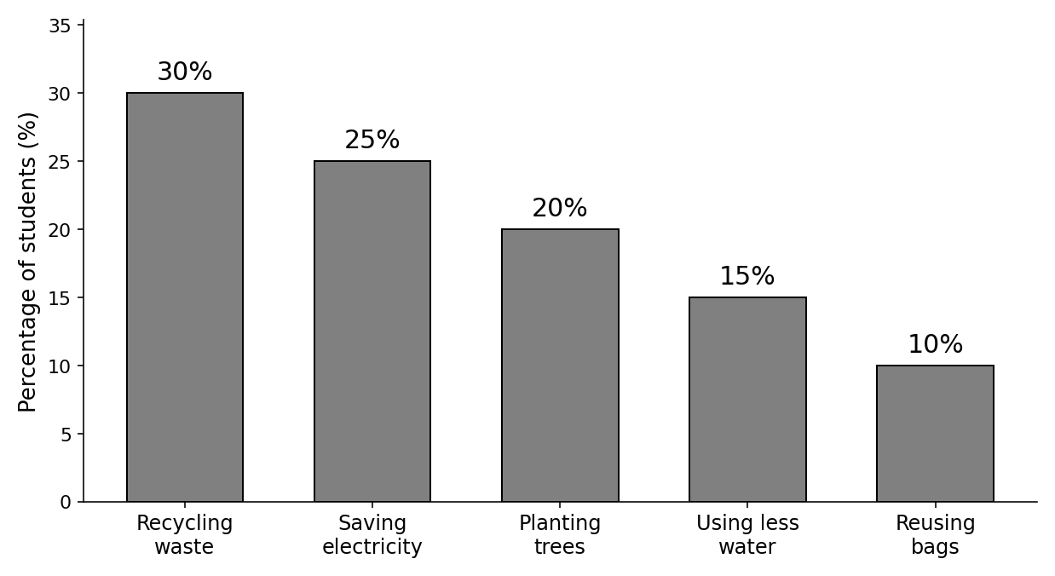

Your writing should be clear and well-organised.

WRITING 1 (continued)

Marker A | Marker B | Average |  | (___________________________)
 |  |  |  | (___________________________) | 5

WRITING 2 (10 marks)
Complete the following narrative writing task. Write at least 100 words.
You were taking part in a beach clean-up with your classmates when something unexpected happened. Write a story about what happened and how you dealt with it.

Your writing should be clear and interesting.

WRITING 2 (continued)

Marker A | Marker B | Average |  | (___________________________)
 |  |  |  | (___________________________) | 10

