

ENGLISH LANGUAGE TEST
GRADE TEN
Academic Year -2026/2027
Semester One _ First Session
(Practice Exam - Unit 1: New Media)

Name
School |  | Class

Write your answers on the Test Paper Total Marks: 60
Time: 2½ hours Pages: 14

ELEMENT |  | Marks |  | Signature with Name
 |  | In Numbers | In Words | First Marker | Second Marker
LISTENING | 15
VOCABULARY | 5
GRAMMAR | 5
READING | 20
WRITING | 15
TOTAL | 60
Prepared by Mohamed Mostafa Al Shorbagy, Regional Supervisor, Wusta Governorate
LISTENING 1 (Items 1-7) (7 marks)
You are going to hear a conversation between two students, Aisha and Salim.
Listen, and shade in the bubble next to the correct option.

1. | What is the podcast episode about?
 |  | making videos |  | staying safe online |  | using group chats
2. | When will they record the episode?
 |  | on Sunday |  | on Monday |  | on Tuesday
3. | Who is Mr Hamed?
 |  | the club leader |  | the computer teacher |  | a journalist
4. | How long should the episode be?
 |  | about ten minutes |  | about twenty minutes |  | about forty minutes
5. | What will Salim prepare tonight?
 |  | the intro music |  | the poster |  | the headphones
6. | What went wrong last time?
 |  | The camera broke. |  | Half the episode was missing. |  | The website stopped.
7. | Where will Aisha put the poster?
 |  | on the club's homepage |  | on the classroom wall |  | in the school magazine

LISTENING 2 (Items 8-15) (8 marks)
You are going to hear a talk about the history of the Internet.
Task One: Listen and for each item, write a short answer (not more than FOUR WORDS or a NUMBER).

8. When did the Internet start?
__________________________________________________
9. How many computers did ARPANET connect at first?
___________________________________________________
10. Who chose the @ symbol for email addresses?
___________________________________________________
11. Where was Tim Berners-Lee working when he invented the Web?
_________________________________________________

Task Two: Listen For each item, shade in the bubble next to the correct option.

 | Statements | True | False
12. | Ray Tomlinson invented the World Wide Web.
13. | Home Internet connections in the 1990s were slow.
14. | Most people today go online on smart phones.
15. | The club's podcast will be about the history of email.

LISTENING
SCORE
LISTENING  SCORE | 15
VOCABULARY (Items 1-5) (5 marks)
For each item, shade in the bubble next to the correct option.
Last week, our media club made a short video for the school (1) ______. Before we started, our teacher asked us to (2) ______ a new account with a strong password. We filmed the video with a tablet, and then we learnt how to (3) ______ it to the club's page. Many students watched it and left a kind (4) ______ below it. Our teacher was very happy. She said the project taught us to use (5) ______ in a safe and useful way.

1.
 |  | newspaper |  | website |  | magazine |  | radio
2.
 |  | hurry up |  | look up |  | set up |  | bring up
3.
 |  | upload |  | disappear |  | download |  | trust
4.
 |  | button |  | screen |  | menu |  | comment
5.
 |  | violence |  | journalism |  | technology |  | brand

VOCABULARY
SCORE
VOCABULARY  SCORE | 5

GRAMMAR (Items 1–5) (5 marks)
For each item, shade in the bubble under the correct option.
Speaker A: | Hi Noor. I'm choosing a new tablet for my school projects. Can you help me?
Speaker B: | Of course! Is the MaxTab (1) better / best ___________ than the LitePad, do you think?
Speaker A: | Yes, it is. Its camera takes (2) clearer / clearest ___________ photos, and the battery lasts longer.
Speaker B: | That's good. But it isn't (3) as / than ___________ cheap as the LitePad, is it?
Speaker A: | True. But my old tablet is the (4) worse / worst ___________ device ever!
Speaker B: | OK. (5) Why don't / How about ___________ we check the prices online first?
Speaker A: | Great idea. Let's compare the two models now and choose one.

GRAMMAR
SCORE
GRAMMAR  SCORE | 5

READING 1 (Items 1-10) (10 marks)
Read the text. Then, complete the tasks.
Last month, fifteen-year-old Hamad Al Balushi joined the media club at his school in Muscat. The club meets every Wednesday in the media room, and more than twenty students take part. He wanted to become a blogger, but the club leader, Ms Salma, asked him to make a podcast instead. "Our followers prefer listening to reading," she explained.
For his first episode, Hamad decided to interview the school's football captain, Younis. He wanted the episode to be perfect because it was his first one. He wrote twelve questions and practised them at home with his younger brother. His brother laughed at his serious voice, so Hamad practised again in front of the mirror.
On the recording day, everything went wrong. First, Hamad forgot to turn on the microphone, so they recorded five minutes of silence. Then, when he tried to edit the file on his tablet, he deleted the best part by mistake. Younis smiled and said, "Don't worry. Let's record it again. The second try is always better."
They recorded the interview once more, and this time Hamad checked everything twice: the microphone, the tablet and the room. When he edited the episode, he added soft music at the beginning and at the end.
Ms Salma uploaded the episode to the school website on Thursday evening. By Friday morning, three hundred students had listened to it. Many followers wrote kind comments below the episode. Some students even stopped Hamad in the corridor to say well done. One comment said, "The questions were interesting and the sound was clear. When is the next episode?"
Hamad was delighted, and his younger brother now wants to join the media club too. But Hamad also learnt an important lesson. Now he always backs up his files in two places and tests the microphone before every recording. "Technology is wonderful," he says, "but only when you know how to deal with its problems."
Next month, Hamad is going to interview a journalist from a local newspaper. He is already writing his questions, and this time he will check the microphone three times. He can hardly wait!

READING 1 (continued)
Task One: for each item, shade in the bubble next to the correct option.

1. | Why did Hamad join the media club?
 |  | to become a blogger |  |  | to make a podcast |  |  |  | to interview Younis
2. | Who was Hamad's first interview with?
 |  | Ms Salma |  |  | the football captain |  |  |  | his younger brother
3. | What happened first on the recording day?
 |  | The microphone was off. |  |  |  | He deleted the file. |  |  |  | The tablet broke.

4. | 'The second try is always better' shows Younis was
 |  | angry |  | encouraging |  | surprised
5. | When was the episode uploaded?
 |  | on Thursday evening |  | on Friday morning |  | on Sunday evening
6. | Before every recording now, Hamad always
 |  | writes twelve questions |  | adds soft music |  | tests the microphone

Task Two: For each item, completer the missing words (not more than two words).
7. Hamad practised the questions with his younger _______________ .
8. He deleted the best part of the file by _______________ .
9. Three _______________ students had listened by Friday morning.
10. Next month, he will interview a _______________ from a local newspaper.

READING 2 (Items 11-20) (10 marks)
Read the text. Then, complete the tasks.

Every morning, thousands of Omani students put a small computer in their pockets and walk to school. The smart phone is probably the most powerful learning tool in history, yet many teachers believe it is also the biggest enemy of attention. So, is the smart phone a tool or a trap?
There is a strong case for phones in class. First, students can look up new English words in seconds instead of carrying heavy dictionaries. Second, educational apps make practice fun: my younger cousin learnt fifty English words in a month using a vocabulary game. Finally, phones allow shy students to participate. In one Muscat school, students answer the teacher's questions through an app, and students who never raise their hands now write answers in every lesson.
However, the case against phones is equally strong. Research suggests that the average attention span falls when a phone is on the desk, even when it is switched off. Social media is designed to keep us glued to our screens: one short video leads to another, and twenty minutes disappear. Worse, some students use phones to mock classmates online. Cyber bullying is harder to see than playground bullying, so teachers often notice it late.
There is also the problem of fake news. When students search for information, they often trust the first website they find. A phone gives quick answers, but not always correct ones. Learning to check sources takes time and guidance from teachers.
Parents play a role too. Many parents give their children phones but never talk about screen time. Families who agree on simple rules, such as no phones during dinner or homework, usually see better results. A phone in a child's pocket needs an awake mind at home as well as at school.

READING 2 (continued)

So what is the answer? In my opinion, a total ban wastes a wonderful tool, but total freedom invites distraction. The best solution is controlled use: phones stay in bags during explanations, and come out only for planned activities, such as dictionary work or quiz apps. Schools should also teach digital self-control as a real skill, like reading or writing.
The smart phone is like fire: it can cook your dinner or burn your house. The phone itself is neither good nor bad. What matters is how, when and why we use it. Schools that teach students to control their phones, rather than fear them, will prepare them best for the digital age.

Task One: For each item, write a short answer (not more than FOUR WORDS or a NUMBER).

11. What did the writer's cousin use to learn English words?

__________________________________

12. How do shy students answer questions in one Muscat school?

___________________________________

13. What falls when a phone is on the desk?

___________________________________

14. Why do teachers often notice cyber bullying late?

___________________________________

15. What do students often trust when they search for information?

___________________________________

16. Where should phones stay during explanations?

___________________________________
Task Two: For each item, shade in the bubble to indicate whether the statement is True/False.
 | Statements | True | False
17. | The writer wants a total ban on smart phones in schools.
18. | The writer's cousin learnt fifty English words in a month.
19. | Students usually check their sources of online information carefully.
20. | The writer compares the smart phone to fire.

READING
SCORE
READING  SCORE | 20

WRITING 1 (5 marks)
Write a text including all the information in the graph/figure below. Write at least 80 words.
"Grade 10 Students' Favourite Online Activities"
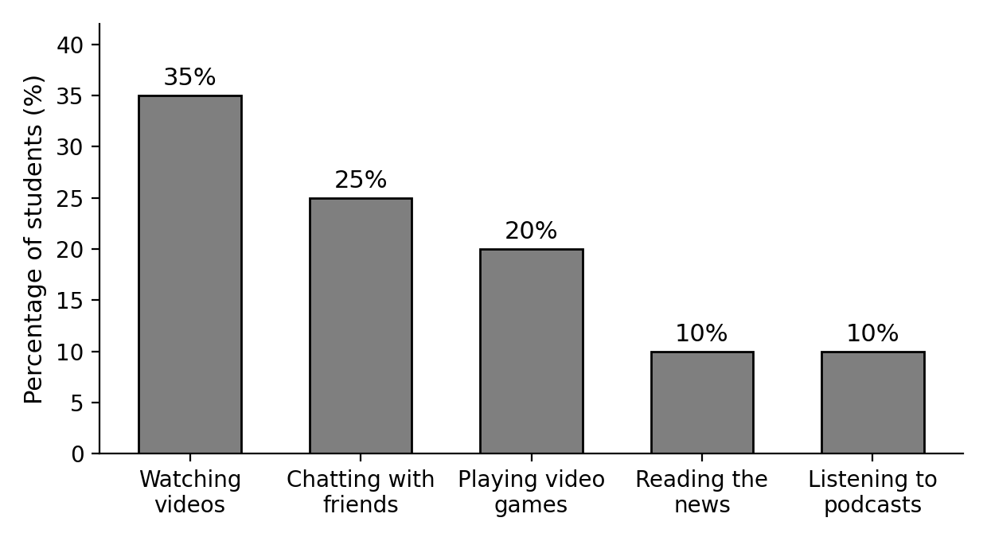

Your writing should be clear and well-organised.

WRITING 1 (continued)

Marker A | Marker B | Average |  | (___________________________)
 |  |  |  | (___________________________) | 5

WRITING 2 (10 marks)
Complete the following narrative writing task. Write at least 100 words.
You were making a video for your school website when something unexpected happened. Write a story about what happened and how you dealt with it.

Your writing should be clear and interesting.

WRITING 2 (continued)

Marker A | Marker B | Average |  | (___________________________)
 |  |  |  | (___________________________) | 10

