

ENGLISH LANGUAGE TEST
GRADE TEN
Academic Year -2026/2027
Semester One _ First Session
(Practice Exam - End of Semester 1 - Exam 3)

Name
School |  | Class

Write your answers on the Test Paper Total Marks: 60
Time: 2½ hours Pages: 14

ELEMENT |  | Marks |  | Signature with Name
 |  | In Numbers | In Words | First Marker | Second Marker
LISTENING | 15
VOCABULARY | 5
GRAMMAR | 5
READING | 20
WRITING | 15
TOTAL | 60

Prepared by Mohamed Mostafa Al Shorbagy, Regional Supervisor, Wusta Governorate

LISTENING 1 (Items 1-7) (7 marks)
You are going to hear a conversation between a reporter, Salim, and a student, Aisha.
Listen, and shade in the bubble next to the correct option.

1. | What is Aisha's app called?
 |  | StudyPal |  | CodeMaster |  | Homework Hub
2. | How did she get the idea for the app?
 |  | from a TV advert |  | from her little brother |  | from a school trip
3. | How long did it take to build the app?
 |  | about four weeks |  | about four months |  | about four years
4. | Who guided Aisha in programming?
 |  | her father |  | an online tutor |  | her IT teacher
5. | How many students entered the competition?
 |  | more than 300 |  | more than 130 |  | more than 30
6. | Where was the final event held?
 |  | at her school |  | in Muscat |  | in Salalah
7. | What feature will she add next month?
 |  | a games feature |  | a reminder to take breaks |  | a chat feature

LISTENING 2 (Items 8-15) (8 marks)
You are going to hear a talk about Oman's seafaring history.
Task One: Listen and for each item, write a short answer (not more than FOUR WORDS or a NUMBER).

8. What is Oman's most famous traditional ship?
__________________________________________________
9. Name one product Omani traders carried abroad.
___________________________________________________
10. When did Ahmad bin Majid live?
___________________________________________________
11. Where do craftsmen still build dhows by hand?
_________________________________________________

Task Two: Listen For each item, shade in the bubble next to the correct option.

 | Statements | True | False
12. | Dhows have a large triangular sail.
13. | Omani sailors only travelled to India.
14. | Ahmad bin Majid wrote books about navigation.
15. | Dhow builders in Sur use modern plans.

LISTENING
SCORE
LISTENING  SCORE | 15
VOCABULARY (Items 1-5) (5 marks)
For each item, shade in the bubble next to the correct option.
Renewable energy is becoming very important in Oman. Unlike (1) ______ fuels such as oil and coal, the sun and the wind will never run out. Solar parks (2) ______ electricity from sunlight, while tall turbines use the wind. Clean energy helps to (3) ______ the environment because it does not pollute the air. The government wants to (4) ______ new solar and wind projects in every region. If we use our natural (5) ______ wisely, Oman can have a bright and clean energy future.

1.
 |  | fossil |  | fresh |  | formal |  | final
2.
 |  | waste |  | generate |  | hide |  | borrow
3.
 |  | damage |  | disturb |  | protect |  | control
4.
 |  | delay |  | delete |  | develop |  | demand
5.
 |  | resources |  | reasons |  | results |  | roads

VOCABULARY
SCORE
VOCABULARY  SCORE | 5

GRAMMAR (Items 1–5) (5 marks)
For each item, shade in the bubble under the correct option.
Speaker A: | Hi Marwa. Have you visited the new recycling centre that opened near our school?
Speaker B: | Yes, I (1) have visited / visited ___________ it with my class last week.
Speaker A: | What do you think of it? Plastic, paper and metal (2) separate / are separated ___________ into different boxes there.
Speaker B: | It's brilliant. So far, the centre (3) collected / has collected ___________ more than two tonnes of plastic.
Speaker A: | That's amazing! I (4) have never seen / never saw ___________ so many recycling boxes in one place.
Speaker B: | Next month, a second centre (5) will open / opens ___________ in our neighbourhood.
Speaker A: | Great news. Our city is getting greener every day!

GRAMMAR
SCORE
GRAMMAR  SCORE | 5

READING 1 (Items 1-10) (10 marks)
Read the text. Then, complete the tasks.
When thirteen-year-old Rashid Al Balushi moved with his family from Muscat to the small coastal town of Sur, he felt sad. He had left his friends, his school and his football team behind. His grandfather, an old fisherman, promised to show him the beauty of the sea, but Rashid was not interested.
One morning in April, his grandfather woke him before sunrise. "Today you will come with me," he said. Rashid followed him to the harbour, where a small wooden boat waited. The sky was still dark, and the water looked black and cold.
As they sailed out, the sun rose slowly behind the mountains, painting the sea gold. Hundreds of small silver fish jumped beside the boat, and a group of dolphins followed them for nearly an hour. Rashid forgot his phone in his pocket and watched everything with wide eyes.
At nine o'clock, his grandfather taught him how to pull the net. It was heavy, and the rope hurt Rashid's hands, but he did not stop. When the net came up, it was full of fish. "The sea gives to those who respect it," his grandfather said, smiling.
They returned at noon with enough fish for the whole family and the neighbours too. That evening, Rashid's grandmother cooked the fish, and the family ate together outside under the stars. Rashid told his grandfather about Muscat, and his grandfather told him stories about sailing to Africa on a dhow when he was young.
The next week, Rashid joined the town's young sailing club. He learned the names of the winds and the stars that sailors use at night. When his old friends from Muscat called him, he told them about the dolphins and the golden sea. "You must visit us," he said proudly. For the first time since the move, Rashid felt that Sur was home.

READING 1 (continued)
Task One: for each item, shade in the bubble next to the correct option.

1. | How did Rashid feel when he moved to Sur?
 |  | happy |  |  | sad |  |  |  | afraid
2. | Who promised to show him the sea?
 |  | his father |  |  | his teacher |  |  |  | his grandfather
3. | What followed the boat for nearly an hour?
 |  | dolphins |  |  |  | seagulls |  |  |  | small fish

4. | What hurt Rashid's hands?
 |  | the fishing net |  | the boat's wheel |  | the rope
5. | What did the family eat in the evening?
 |  | at a restaurant |  | outside under the stars |  | at the harbour
6. | What did Rashid join the next week?
 |  | a football team |  | the sailing club |  | a fishing company

Task Two: For each item, completer the missing words (not more than two words).
7. Rashid's family moved to Sur in the month of _______________ .
8. The sun painted the sea the colour _______________ .
9. Rashid's grandmother _______________ the fish for the family.
10. At the sailing club, Rashid learned the names of the winds and the _______________ .

READING 2 (Items 11-20) (10 marks)
Read the text. Then, complete the tasks.

Water is life, but it is also a limited resource. Oman is one of the driest countries in the world, and every drop matters. As the population grows and cities expand, the demand for water rises every year, while rainfall stays low and unpredictable.
Most of Oman's drinking water does not come from rivers or rain. It comes from the sea. Large desalination plants near the coast remove salt from seawater and turn it into clean water for homes, schools and hospitals. These plants supply most of the water used in Muscat and other big cities. In the countryside, people depend on wells and the ancient falaj channels that carry groundwater to farms and villages.
Both sources face pressure. Underground water levels are falling in many areas because people use more water than the rain can replace. Desalination can fill the gap, but it is expensive and uses a lot of energy. If we waste water today, future generations will pay the price.
The government has started several programmes to protect water resources. New laws stop the digging of illegal wells, and modern irrigation systems help farmers use less water. Treated wastewater from cities is cleaned and reused to water parks and street trees instead of being thrown away.

READING 2 (continued)

Families can make a big difference too. Simple habits - fixing dripping taps, taking shorter showers, and watering gardens early in the morning - can save thousands of litres every year. Schools teach children that water is precious, and many mosques now use water-saving taps for ablution.
Experts say the answer lies in using every source wisely: the sea, the ground and the rain. Oman has survived for centuries in a dry land thanks to the wisdom of its people. With modern technology and old wisdom together, the country can keep its water flowing for generations to come.

Task One: For each item, write a short answer (not more than FOUR WORDS or a NUMBER).

11. Where does most of Oman's drinking water come from?

__________________________________

12. What do desalination plants remove from seawater?

___________________________________

13. Name one reason underground water levels are falling.

___________________________________

14. What is treated wastewater reused for?

___________________________________

15. Name one simple habit that saves water at home.

___________________________________

16. What stops the digging of illegal wells?

___________________________________
Task Two: For each item, shade in the bubble to indicate whether the statement is True/False.
 | Statements | True | False
17. | Rainfall in Oman is high and predictable.
18. | Desalination uses a lot of energy.
19. | Treated wastewater is thrown away.
20. | Experts say only one water source should be used.

READING
SCORE
READING  SCORE | 20

WRITING 1 (5 marks)
Write a text including all the information in the graph/figure below. Write at least 80 words.
"How an Omani Family Uses Water at Home"
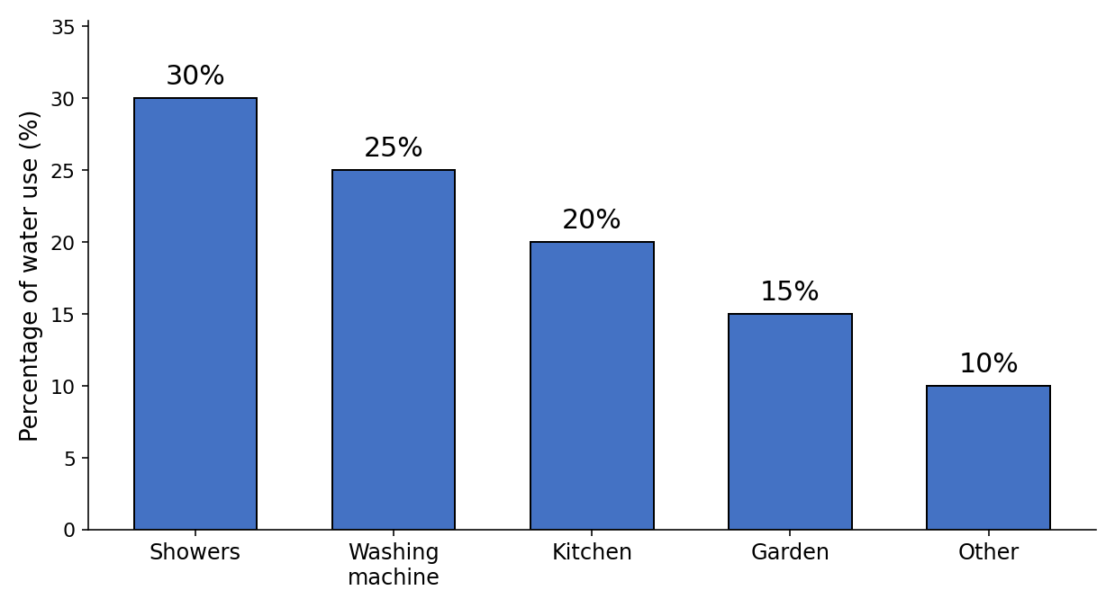

Your writing should be clear and well-organised.

WRITING 1 (continued)

Marker A | Marker B | Average |  | (___________________________)
 |  |  |  | (___________________________) | 5

WRITING 2 (10 marks)
Complete the following narrative writing task. Write at least 100 words.
Write a story about a time when you worked hard to achieve a goal: what the goal was, what difficulties you faced, and how you felt when you succeeded.

Your writing should be clear and interesting.

WRITING 2 (continued)

Marker A | Marker B | Average |  | (___________________________)
 |  |  |  | (___________________________) | 10

