

ENGLISH LANGUAGE TEST
GRADE TEN
Academic Year -2026/2027
Semester One _ First Session
(Practice Exam - End of Semester 1 - Exam 2)

Name
School |  | Class

Write your answers on the Test Paper Total Marks: 60
Time: 2½ hours Pages: 14

ELEMENT |  | Marks |  | Signature with Name
 |  | In Numbers | In Words | First Marker | Second Marker
LISTENING | 15
VOCABULARY | 5
GRAMMAR | 5
READING | 20
WRITING | 15
TOTAL | 60

Prepared by Mohamed Mostafa Al Shorbagy, Regional Supervisor, Wusta Governorate

LISTENING 1 (Items 1-7) (7 marks)
You are going to hear a conversation between a reporter, Nasser, and a student, Mona.
Listen, and shade in the bubble next to the correct option.

1. | What does Mona's club do?
 |  | plant trees and recycle |  | clean the school pool |  | paint classrooms
2. | When did the club begin its work?
 |  | last June |  | last September |  | last week
3. | How many students have joined the club?
 |  | about sixteen |  | about sixty |  | about six hundred
4. | Where does the club meet?
 |  | in the library |  | in the school garden |  | in the science hall
5. | Who helps organise the activities?
 |  | Mr Rashid |  | the headteacher |  | Mona's father
6. | What was the club's biggest project this year?
 |  | cleaning the beach |  | planting eighty trees |  | building a garden
7. | What will the club build next?
 |  | a small school garden |  | a new science lab |  | a recycling factory

LISTENING 2 (Items 8-15) (8 marks)
You are going to hear a talk about wind energy in Oman.
Task One: Listen and for each item, write a short answer (not more than FOUR WORDS or a NUMBER).

8. Which region of Oman has excellent wind?
__________________________________________________
9. When did the Harweel wind farm open?
___________________________________________________
10. How many homes can the Harweel turbines power?
___________________________________________________
11. What must engineers protect when placing turbines?
_________________________________________________

Task Two: Listen For each item, shade in the bubble next to the correct option.

 | Statements | True | False
12. | The Harweel turbines are about 150 metres tall.
13. | Wind energy produces some greenhouse gases.
14. | The wind blows at the same speed all the time.
15. | Oman plans to use more clean electricity by 2030.

LISTENING
SCORE
LISTENING  SCORE | 15
VOCABULARY (Items 1-5) (5 marks)
For each item, shade in the bubble next to the correct option.
Our planet is getting warmer, and climate change is already affecting life in Oman. If we want to (1) ______ the environment for our children, we must act now. Factories and cars produce harmful gases that (2) ______ the air in big cities. Using buses and bicycles instead of private cars can (3) ______ this problem. Families can also help by saving electricity and water at home. Finally, schools should (4) ______ students to care about nature through projects and trips. If everyone works together, we can build a greener and (5) ______ future for our country.

1.
 |  | protect |  | pretend |  | prepare |  | prevent
2.
 |  | clean |  | pollute |  | measure |  | collect
3.
 |  | increase |  | create |  | reduce |  | repeat
4.
 |  | describe |  | destroy |  | discover |  | encourage
5.
 |  | cleaner |  | darker |  | smaller |  | slower

VOCABULARY
SCORE
VOCABULARY  SCORE | 5

GRAMMAR (Items 1–5) (5 marks)
For each item, shade in the bubble under the correct option.
Speaker A: | Hi Salim. Are you coming to the Earth Hour event at school tonight?
Speaker B: | Of course! Our class (1) has prepared / prepared ___________ a short play about saving energy.
Speaker A: | Great. Last year the event (2) was watched / watched ___________ by more than two hundred students.
Speaker B: | I remember! The lights (3) turned off / were turned off ___________ for one hour.
Speaker A: | This year the play is longer than the one we (4) have seen / saw ___________ last year.
Speaker B: | I hope it (5) will win / wins ___________ the school competition too.
Speaker A: | I'm sure it will. See you tonight!

GRAMMAR
SCORE
GRAMMAR  SCORE | 5

READING 1 (Items 1-10) (10 marks)
Read the text. Then, complete the tasks.
Last spring, twelve-year-old Hamed Al Riyami travelled with his class from Nizwa to the ancient village of Misfat Al Abriyeen. Hamed loved history, but he had never visited an old mountain village before. His grandfather often told him stories about the days when traders crossed the mountains with camels, carrying dates and frankincense to the coast.
The bus climbed the narrow road up the mountain, and the students looked down at the deep valley below. When they arrived, their guide, an old man named Salim, welcomed them at the village gate. He wore a traditional dishdasha and carried a wooden stick that had belonged to his grandfather.
Salim led the class along stone paths between tall mud-brick houses. He showed them the falaj, a channel of cool water that had brought life to the village gardens for more than a thousand years. Hamed touched the water and imagined the workers who had dug the channel through hard rock without modern machines.
At noon, the students sat in the shade of a huge date palm and ate their sandwiches. Salim told them how villagers dried dates in the sun and stored them in clay pots for the long summers. He explained that every family shared the falaj water by a system of turns that everyone respected.
Before leaving, the class visited a small museum inside an old house. Hamed saw silver jewellery, copper coffee pots and handwritten letters that were two hundred years old. He wrote everything carefully in his notebook.
On the bus home, Hamed opened his notebook and began to draw the village from memory. His teacher looked at the drawing and smiled. "You should enter the national heritage competition," she said. Three months later, Hamed's drawing of Misfat Al Abriyeen won second prize, and it was printed in a school magazine. His proud grandfather framed the page and hung it in the majlis for every visitor to see.

READING 1 (continued)
Task One: for each item, shade in the bubble next to the correct option.

1. | Where did Hamed's class travel?
 |  | to a mountain village |  |  | to the capital city |  |  |  | to a coastal town
2. | What did traders carry to the coast?
 |  | silver and gold |  |  | dates and frankincense |  |  |  | clay pots
3. | Who was Salim?
 |  | Hamed's grandfather |  |  |  | the bus driver |  |  |  | the village guide

4. | What had brought water to the gardens?
 |  | the falaj |  | deep wells |  | rain pipes
5. | How were dates stored for the summer?
 |  | in freezers |  | in clay pots |  | in wooden boxes
6. | What did Hamed win?
 |  | first prize in drawing |  | a trip to the coast |  | second prize in a competition

Task Two: For each item, completer the missing words (not more than two words).
7. Hamed's class travelled to Misfat Al Abriyeen in the season of _______________ .
8. Salim carried a wooden _______________ that had belonged to his grandfather.
9. The falaj had brought water to the village for more than a thousand _______________ .
10. Hamed's grandfather hung the magazine page in the _______________ .

READING 2 (Items 11-20) (10 marks)
Read the text. Then, complete the tasks.

The Earth is warming, and the effects of climate change can already be seen in Oman. Summers are becoming longer and hotter, rainfall is less predictable, and the sea is slowly rising along parts of the coast. Scientists agree that the main cause is the burning of oil, gas and coal, which fills the atmosphere with greenhouse gases.
Climate change touches every part of life. Farmers find it harder to grow crops when the rain arrives late or not at all. Fishermen report that some fish are moving to cooler, deeper waters. In the mountains, the ancient falaj systems depend on steady groundwater, which falls when droughts last longer. Even cities feel the change: demand for electricity rises every summer as families run their air conditioners for more hours.
The good news is that Oman is taking action. The government has opened solar parks and wind farms, and it plans to produce a third of the country's electricity from clean sources by 2030. New buildings must follow rules that save energy, and several cities are planting thousands of trees to provide shade and absorb carbon.
Schools and families have an important role too. When students learn to switch off lights, save water and recycle, these habits spread to their homes. Many Omani schools now hold environment weeks, plant gardens and take students to see solar parks. Teachers say young people are often more serious about the planet than adults.

READING 2 (continued)

Experts warn that no single solution will stop climate change. Countries must work together, because the atmosphere belongs to everyone, and every person must accept small changes in daily life.
The choices we make today will decide the world our grandchildren inherit. A cooler, cleaner future is still possible, but only if governments, businesses and ordinary families act now, not tomorrow.

Task One: For each item, write a short answer (not more than FOUR WORDS or a NUMBER).

11. What is the main cause of climate change, according to scientists?

__________________________________

12. Name one problem farmers face from climate change.

___________________________________

13. Where are some fish moving to?

___________________________________

14. How much electricity should come from clean sources by 2030?

___________________________________

15. What are several cities planting to provide shade?

___________________________________

16. Who must work together, according to experts?

___________________________________
Task Two: For each item, shade in the bubble to indicate whether the statement is True/False.
 | Statements | True | False
17. | Rainfall in Oman is becoming less predictable.
18. | Demand for electricity falls every summer.
19. | Some Omani schools take students to see solar parks.
20. | Experts say one single solution can stop climate change.

READING
SCORE
READING  SCORE | 20

WRITING 1 (5 marks)
Write a text including all the information in the graph/figure below. Write at least 80 words.
"How Grade 10 Students Travel to School"
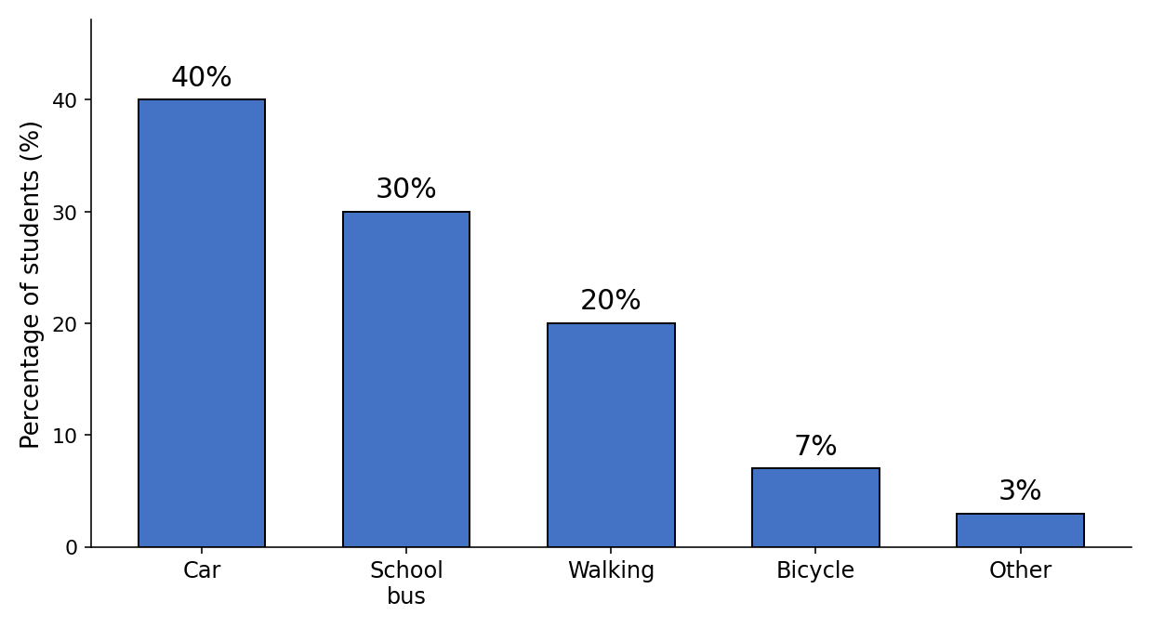

Your writing should be clear and well-organised.

WRITING 1 (continued)

Marker A | Marker B | Average |  | (___________________________)
 |  |  |  | (___________________________) | 5

WRITING 2 (10 marks)
Complete the following narrative writing task. Write at least 100 words.
Write a story about a visit you made to an old or historical place in Oman: what you saw there, what you learned, and how you felt about the visit.

Your writing should be clear and interesting.

WRITING 2 (continued)

Marker A | Marker B | Average |  | (___________________________)
 |  |  |  | (___________________________) | 10

