

ENGLISH LANGUAGE TEST
GRADE TEN
Academic Year -2026/2027
Semester One _ First Session
(Practice Exam - End of Semester 1 - Exam 1)

Name
School |  | Class

Write your answers on the Test Paper Total Marks: 60
Time: 2½ hours Pages: 14

ELEMENT |  | Marks |  | Signature with Name
 |  | In Numbers | In Words | First Marker | Second Marker
LISTENING | 15
VOCABULARY | 5
GRAMMAR | 5
READING | 20
WRITING | 15
TOTAL | 60

Prepared by Mohamed Mostafa Al Shorbagy, Regional Supervisor, Wusta Governorate

LISTENING 1 (Items 1-7) (7 marks)
You are going to hear a conversation between a reporter, Salwa, and a student, Ahmed.
Listen, and shade in the bubble next to the correct option.

1. | What is Ahmed's club making?
 |  | a school newspaper |  | a weekly podcast |  | a class website
2. | What was the first episode about?
 |  | plastic in the sea |  | electric cars |  | school lunches
3. | How many students listened to the first episode?
 |  | about forty |  | about one hundred |  | more than four hundred
4. | Where do the students record their episodes?
 |  | in a studio next to the library |  | in the science lab |  | in Ahmed's house
5. | Who checks the club's scripts?
 |  | the headteacher |  | Ms Helen |  | an engineer
6. | What will the next episode be about?
 |  | solar energy in Oman |  | beach cleaning |  | online safety
7. | When will the next episode be published?
 |  | on Sunday |  | next Thursday |  | next year

LISTENING 2 (Items 8-15) (8 marks)
You are going to hear a talk about solar energy in Oman.
Task One: Listen and for each item, write a short answer (not more than FOUR WORDS or a NUMBER).

8. How many days a year do most areas of Oman receive strong sunshine?
__________________________________________________
9. When did Oman open its first large solar park?
___________________________________________________
10. Where is the Ibri Two solar park?
___________________________________________________
11. What can cover the solar panels?
_________________________________________________

Task Two: Listen For each item, shade in the bubble next to the correct option.

 | Statements | True | False
12. | Solar panels produce harmful gases.
13. | Sunshine is free once a solar park is built.
14. | Batteries store solar energy for the night.
15. | All Omani schools have solar panels on their roofs.

LISTENING
SCORE
LISTENING  SCORE | 15
VOCABULARY (Items 1-5) (5 marks)
For each item, shade in the bubble next to the correct option.
Social media has changed the way young people (1) ______ with each other. Instead of meeting after school, many teenagers send messages and share videos online. This can be useful, but it also has (2) ______ . Some students spend so much time on their phones that they sleep badly and find it hard to (3) ______ on their schoolwork. Doctors advise teenagers to (4) ______ their screen time to two hours a day. Parents and teachers should also talk to young people about staying (5) ______ online.

1.
 |  | communicate |  | calculate |  | celebrate |  | complain
2.
 |  | advantages |  | disadvantages |  | addresses |  | adventures
3.
 |  | depend |  | concentrate |  | decide |  | travel
4.
 |  | increase |  | waste |  | limit |  | charge
5.
 |  | healthy |  | wealthy |  | noisy |  | safe

VOCABULARY
SCORE
VOCABULARY  SCORE | 5

GRAMMAR (Items 1–5) (5 marks)
For each item, shade in the bubble under the correct option.
Speaker A: | Hi Khalid. Did you watch the documentary about climate change last night?
Speaker B: | No, but I (1) have read / read ___________ many articles about the subject recently.
Speaker A: | I saw it yesterday. It showed how the Earth's temperature (2) has risen / rose ___________ since 1900.
Speaker B: | That's worrying. Did it say what (3) causes / caused ___________ the problem?
Speaker A: | Yes. Most scientists agree that it (4) is caused / was caused ___________ mainly by burning oil and gas.
Speaker B: | So what can we do? The documentary (5) must watch / must be watched ___________ by every student, I think.
Speaker A: | I agree. I'll ask our teacher to show it in class!

GRAMMAR
SCORE
GRAMMAR  SCORE | 5

READING 1 (Items 1-10) (10 marks)
Read the text. Then, complete the tasks.
When the heavy rain started in Muscat last October, fifteen-year-old Maryam Al Habsi was not worried. Rain was rare in her city, and she loved the sound of it on the windows. But by midnight, the street outside her house had turned into a brown river.
Maryam's father woke the family at two in the morning. Water was entering the garden. Quickly, they carried the carpets, the television and the family photo albums to the second floor. Maryam's little brother, Salim, cried because he could not find his football. Maryam promised to buy him a new one, and he finally smiled.
At four o'clock, the electricity went off. The family sat in the dark and listened to the rain. Then they heard a loud knocking at the door. It was their elderly neighbour, Mr Said. The water had reached the ground floor of his house, and he could not climb his stairs. Maryam's father and older brother carried him carefully through the water and brought him to their home.
The next morning, the rain stopped, but the streets were full of mud and broken trees. Schools were closed for three days. Instead of resting, Maryam and her classmates decided to help. With their teachers, they formed volunteer teams. Some students cleaned houses in the old neighbourhood; others collected clothes, blankets and food for families who had lost everything.
Maryam's team worked in Mr Said's house for two days. They removed the wet furniture, washed the walls and painted the rooms. Mr Said watched them with tears in his eyes. "You are not just students," he told them. "You are heroes."
Two weeks later, the school held a special assembly. The headteacher thanked the volunteers and gave each team a certificate. A local newspaper wrote a story about them, and their photos appeared on its website. Maryam kept a printed copy of the article on her bedroom wall.
"The flood was frightening," Maryam told her friends, "but it taught me something important. A community is not just a place where people live near each other. It is people who help each other when times are hard." The following month, the school started a new volunteer club, and more than one hundred students joined it. Maryam was chosen as its first leader.

READING 1 (continued)
Task One: for each item, shade in the bubble next to the correct option.

1. | How did Maryam feel when the rain started?
 |  | worried |  |  | not worried |  |  |  | angry
2. | What did the family carry to the second floor?
 |  | the car |  |  | the photo albums |  |  |  | the fridge
3. | Why did Salim cry?
 |  | He lost his football |  |  |  | Afraid of the dark |  |  |  | He lost Mr Said

4. | Who knocked at the door at four o'clock?
 |  | a police officer |  | Maryam's teacher |  | the elderly neighbour
5. | What did Maryam's team do in Mr Said's house?
 |  | cooked meals |  | painted the rooms |  | built a new wall
6. | What happened at the special assembly?
 |  | Got certificates |  | A school opened |  | Watched a film

Task Two: For each item, completer the missing words (not more than two words).
7. The heavy rain started in the month of _______________ .
8. Maryam's brother cried because he could not find his _______________ .
9. Some volunteers collected clothes, blankets and _______________ for poor families.
10. Maryam kept a printed copy of the newspaper _______________ on her wall.

READING 2 (Items 11-20) (10 marks)
Read the text. Then, complete the tasks.

Every Omani teenager owns a smartphone, and most spend several hours a day looking at its screen. Some people believe smartphones have destroyed real communication between young people. Others say they have made life better in many ways. Who is right?
Critics of smartphones paint a dark picture. They say teenagers no longer talk to each other face to face. Walk into any cafe and you will see groups of friends sitting together in silence, each one staring at a private screen. Family dinners suffer too: parents compete with videos and games for their children's attention. Worse still, heavy phone use is linked to poor sleep, and tired students cannot learn well. Some doctors even say that social media makes teenagers anxious, because they compare their ordinary lives with the perfect images others post online.
Supporters of smartphones see things differently. A phone, they argue, is a library, a camera, a classroom and a meeting place in one small box. Students use phones to research homework, translate words and watch science videos. During the pandemic, smartphones kept education alive when schools were closed. Phones also connect families: a student in Salalah can see her grandmother in Sohar every evening on a video call, something impossible twenty years ago.
Supporters add that communication has not disappeared - it has changed shape. Teenagers today write more than any generation before them: messages, comments, captions and posts. A shy student who cannot speak in class may express brilliant ideas in a group chat. And when a friend is in trouble, a message can arrive in seconds. For many young people, the phone is not a wall between friends; it is a bridge.

READING 2 (continued)

In my view, the smartphone itself is neither good nor bad; the way we use it decides everything. A knife can cut bread or cause harm, and a phone can connect us or divide us. The answer is not to throw phones away, but to learn to control them.
Families and schools should agree on clear rules: no phones at the dinner table, no phones in bedrooms at night, and no phones during homework. Teenagers who learn self-control will enjoy the best of both worlds - the wealth of the digital age and the warmth of a real conversation. The goal is simple: we should use our phones, not allow our phones to use us.

Task One: For each item, write a short answer (not more than FOUR WORDS or a NUMBER).

11. According to critics, what do parents compete with for their children's attention?

__________________________________

12. What is heavy phone use linked to, besides poor sleep?

___________________________________

13. Name one thing students use phones for, from the text.

___________________________________

14. How did smartphones help education during the pandemic?

___________________________________

15. What does the writer compare the smartphone to?

___________________________________

16. Who should agree on clear phone rules?

___________________________________
Task Two: For each item, shade in the bubble to indicate whether the statement is True/False.
 | Statements | True | False
17. | Critics say friends in cafes always talk to each other.
18. | Supporters say teenagers today write more than earlier generations.
19. | The writer believes phones should be thrown away.
20. | The writer advises no phones in bedrooms at night.

READING
SCORE
READING  SCORE | 20

WRITING 1 (5 marks)
Write a text including all the information in the graph/figure below. Write at least 80 words.
"Grade 10 Students' Favourite Ways of Getting News"
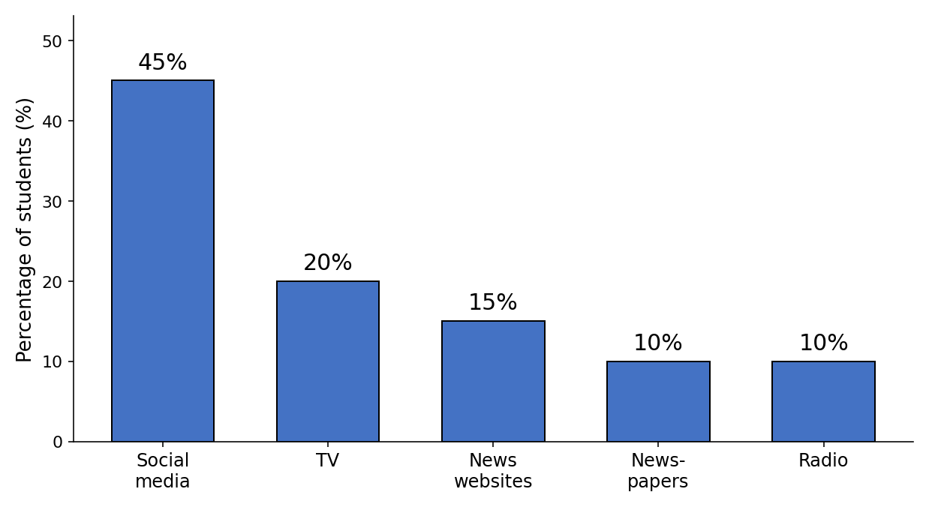

Your writing should be clear and well-organised.

WRITING 1 (continued)

Marker A | Marker B | Average |  | (___________________________)
 |  |  |  | (___________________________) | 5

WRITING 2 (10 marks)
Complete the following narrative writing task. Write at least 100 words.
Write a story about a time when you helped someone in your neighbourhood or community: what happened, what you did, and how you felt afterwards.

Your writing should be clear and interesting.

WRITING 2 (continued)

Marker A | Marker B | Average |  | (___________________________)
 |  |  |  | (___________________________) | 10

